**COVID TEST**

**&**

**VACCINATION SYSTEM**

COVID TEST & VACCINATON SYSTEM

**PROJECT GROUP MEMBERS**

|  |  |
| --- | --- |
| Students id | Students name |
| **Student1426616** | **SYED MUHAMMAD ZAIN SARFRAZ** |
| **Student1419863** | **TOOBA TARIQ** |
| **Student1425117** | **AQSA ABDUL JABBAR** |

**CURRICULUM BATCH**

**7062 2210B3**

**FACULTY**

**SIR EBAD-UDDIN**

**CO-ORDINATOR**

**MISS MUNAZZAH**

COVID TEST & VACCINATION SYSTEM

**Certificate**

This is to certify that the dissertation entitled **“COVID TEST & VACCINATION SYSTEM”** is **SYED MUHAMMAD ZAIN SARFRAZ STUDENT1426616, TOOBA TARIQ Student1419863, and AQSA ABDUL JABBAR Student1425117** in their partial fulfilment of the requirement of the award of the Aptech Computer Certified.

COVID TEST & VACCINATION SYSTEM

**Acknowledgement**

The success and final outcome of this project required a lot of guidance and assistance from many people and I am extremely privileged to have got this all along the completion of my project. All that I have done is only due to such supervision and assistance and I would not forget to thank them.

I respect and thank Aptech for providing me an opportunity to do the project work in ACE and giving us all support and guidance, which made me complete the project duly. I am extremely thankful to Aptech for providing such a nice support and guidance.

I owe my deep gratitude to our project guide **SIR EBAD-UDDIN**, who took keen interest on our project work and guided us all along, till the completion of our project work by providing all the necessary information for developing a good system.

STUDENTY1426616 SYED MUHAMMAD ZAIN SARFRAZ

STUDENT1419863 TOOBA TARIQ

STUDENT1425117 AQSA ABDUL JABBAR

COVID TEST & VACCINATON SYSTEM

**Abstract**

This project is aimed at developing an COVID TEST & VACCINATION SYSTEM for the facilities in the campus. This is an internet based application that can be accessed throughout the campus. This system can be used to automate the workflow of service requests for the various facilities in the campus. This is an integrated system that covers different kinds of facilities like class-rooms, labs, hostels, mess, canteen, gymnasium, computer center, faculty club etc. Registered users (students, faculty, lab-assistants and others) will be able to log in a request for service for any of the supported facilities.

These requests will be sent to the concerned people, who are also valid users of the system, to get them resolved. There are features like email notifications/reminders,

COVID TEST & VACCINATION SYSTEM

# INTRODUCTION

COVID TEST & VACCINATION SYSTEM

**Introduction:**

Across the world, people are facing unforeseen challenges due to Coronavirus

pandemic. Design and develop a web application for online test and vaccination booking

system for patient. The Covid 19 web app connects the people with the hospital and the

administration to come together and fight the pandemic. With this web app, one can

track the vaccination appointment, history and covid solution guidelines for symptoms.

**Modules:**

The entire project mainly consists of 3 modules, which are

* + - Admin
    - hospital
    - patient

#### admin:

#### all patients details

#### report of covid test/vaccination

#### test report, vaccination (date/week/monthly report)

#### list of vaccine

#### approval hospital login

#### list of hospitals

#### booking details

#### hospital:

#### Register

#### Login

#### List of patient details

#### Request from patient (Covid test/Vaccination)

#### Approve or Reject

#### Update Covid test result

#### Update Vaccination status

#### Patient:

#### Register

#### Login

#### List of patient details

#### Request from patient (Covid test/Vaccination)

#### Approve or Reject

#### Update Covid test result

#### Update Vaccination status

COVID TEST & VACCINATION SYSTEM

# 

# REQUIREMENTS

COVID TEST & VACCINATION SYSTEM

**Requirements:**

**User Registration:**

* Admin, Hospital, and Patient should be able to create accounts with their

respective details.

* They must provide necessary information like name, address, and login

credentials (username and password).

**Admin Functions:**

* View All Patient Details: The admin can see profiles of all registered patients.
* COVID-19 Reports: Admin can generate reports on COVID-19 patients,

including test reports, in date-wise formats.

* Vaccine Availability: Admin can check the availability of vaccines.
* Hospital Approval: Admin can approve or reject hospital login requests.
* Hospital Listings: Admin can view details of hospitals**.**
* Booking Details: Admin can view COVID-19 test booking details made by

patients.

**Hospital Functions:**

* Hospital Registration and Login: Hospitals can register and log in with their

details.

* View Patient Details: Hospitals can see the details of patients approved for

COVID-19 tests.

* Patient Requests: Hospitals can receive requests from patients for COVID-19

tests or vaccinations and can approve or reject them.

* Update COVID-19 Results: Hospitals can update the COVID-19 test results for

patients.

* Update Vaccination Status: Hospitals can update the vaccination status of

patients.

**Patient Functions:**

* Patient Registration and Login: Patients can register and log in with their

details.

* Search Hospitals: Patients can search for hospitals offering COVID-19 tests or

vaccinations.

* Request for Testing/Vaccination: Patients can request COVID-19 testing or

vaccinations from hospitals.

* Report Access: Patients can access their COVID-19 test result reports and

vaccination recommendations.

* Hospital Appointments: Patients can book appointments for COVID-19 tests at

hospitals.

View Appointments: Patients can check their appointment details.

* View Results: Patients can view their COVID-19 test results and vaccination

suggestions.

* Profile Management: Patients can check and edit their profile details.
* These requirements aim to create a web application that connects patients with

hospitals for COVID-19 testing and vaccination services. The system allows for

user registration, appointment scheduling, and management of COVID-19-

related data by administrators, hospitals, and patients.

COVID TEST & VACCINATION SYSTEM

# REQUIREMENT SPECIFICATION

COVID TEST & VACCINATION SYSTEM

**Hardware**

* A minimum computer system that will help you access all the tools in the

courses is a Pentium 166 or better

* 128 Megabytes of RAM or better

**Operating System**

* LINUX / Windows 2000 Server (or higher if possible)

**Software**

* PHP
* MySQL
* PERL
* Apache

**DIAGRAM**

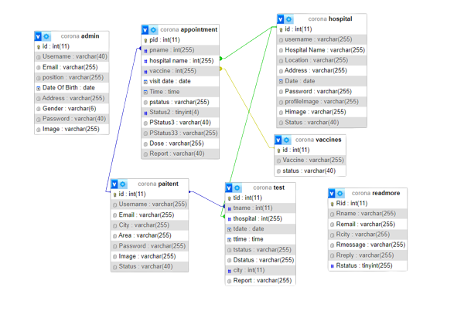

COVID TEST & VACCINATION SYSTEM

**ADMIN**

**SCREENSHOTS**

## LOGIN

## 

**CHANGE PASSWORD**

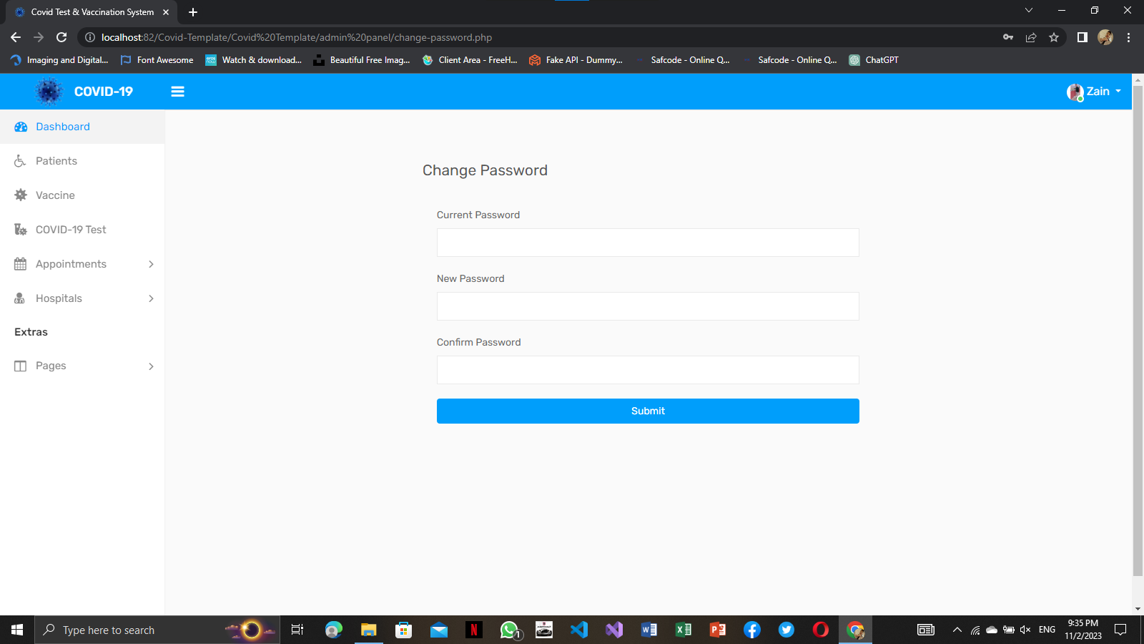

COVID TEST & VACCINATION SYSTEM

## HEADER

## 

**SIDEBAR**

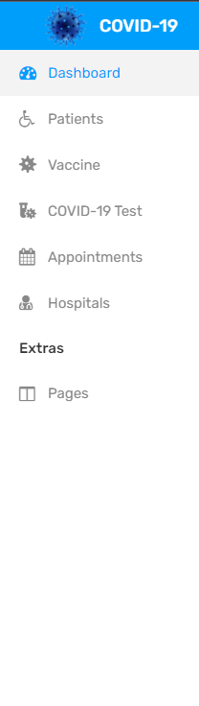

**HOME**

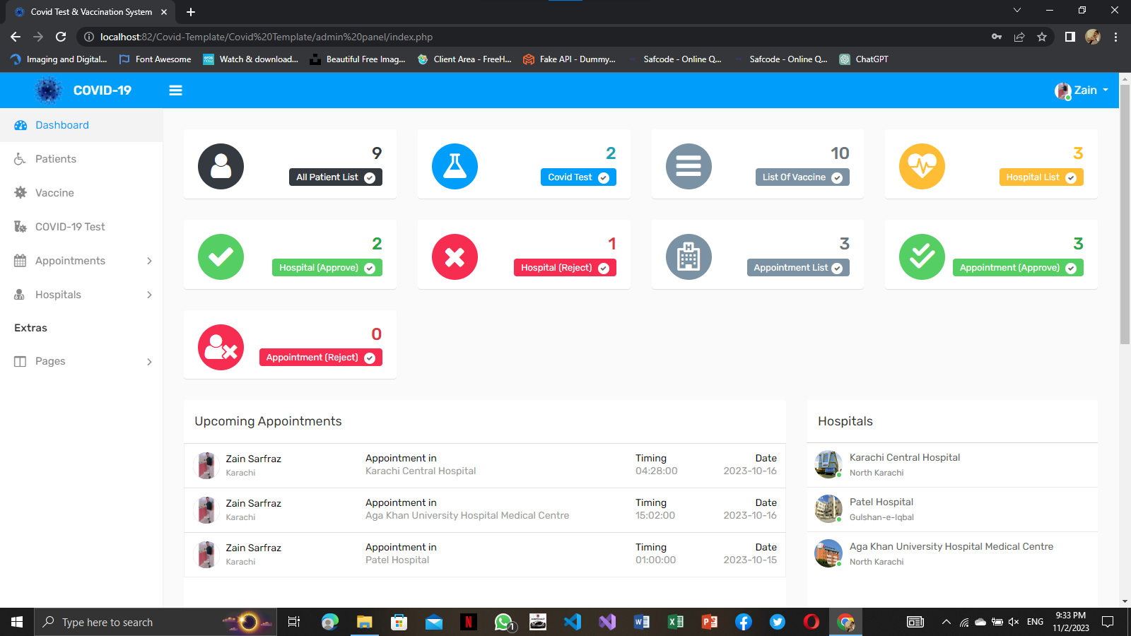

**PROFILE**

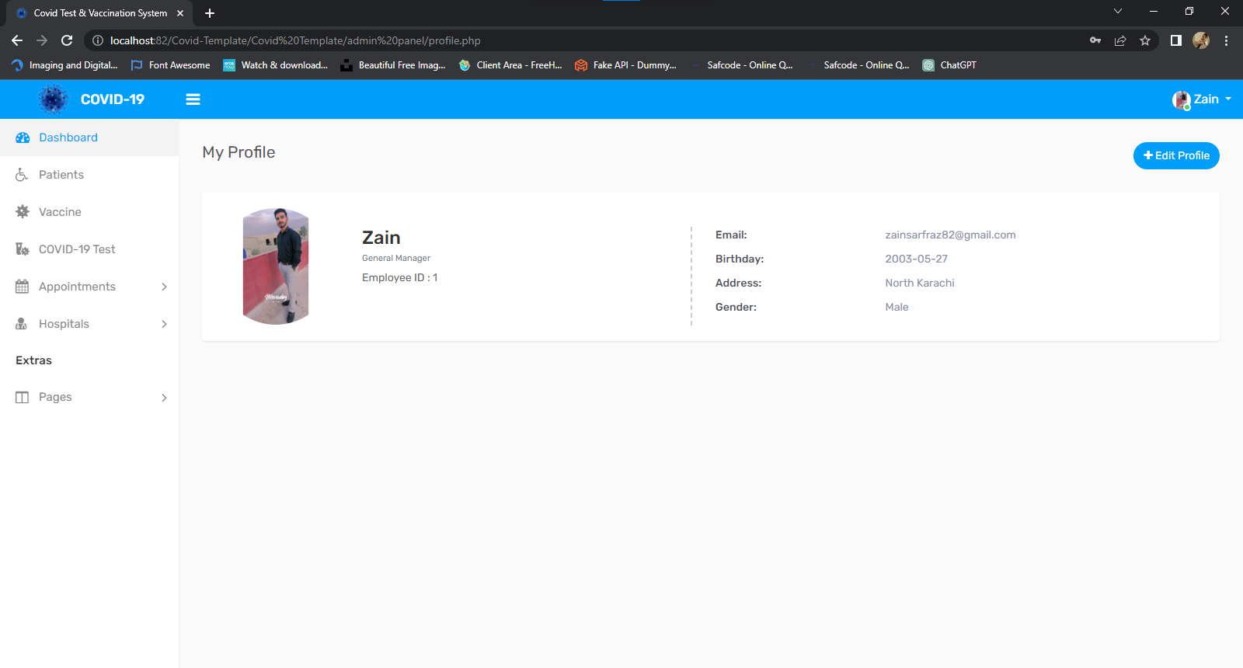

COVID TEST & VACCINATION SYSTEM

## EDIT PROFILE

## 

**COVID TEST VIEW**

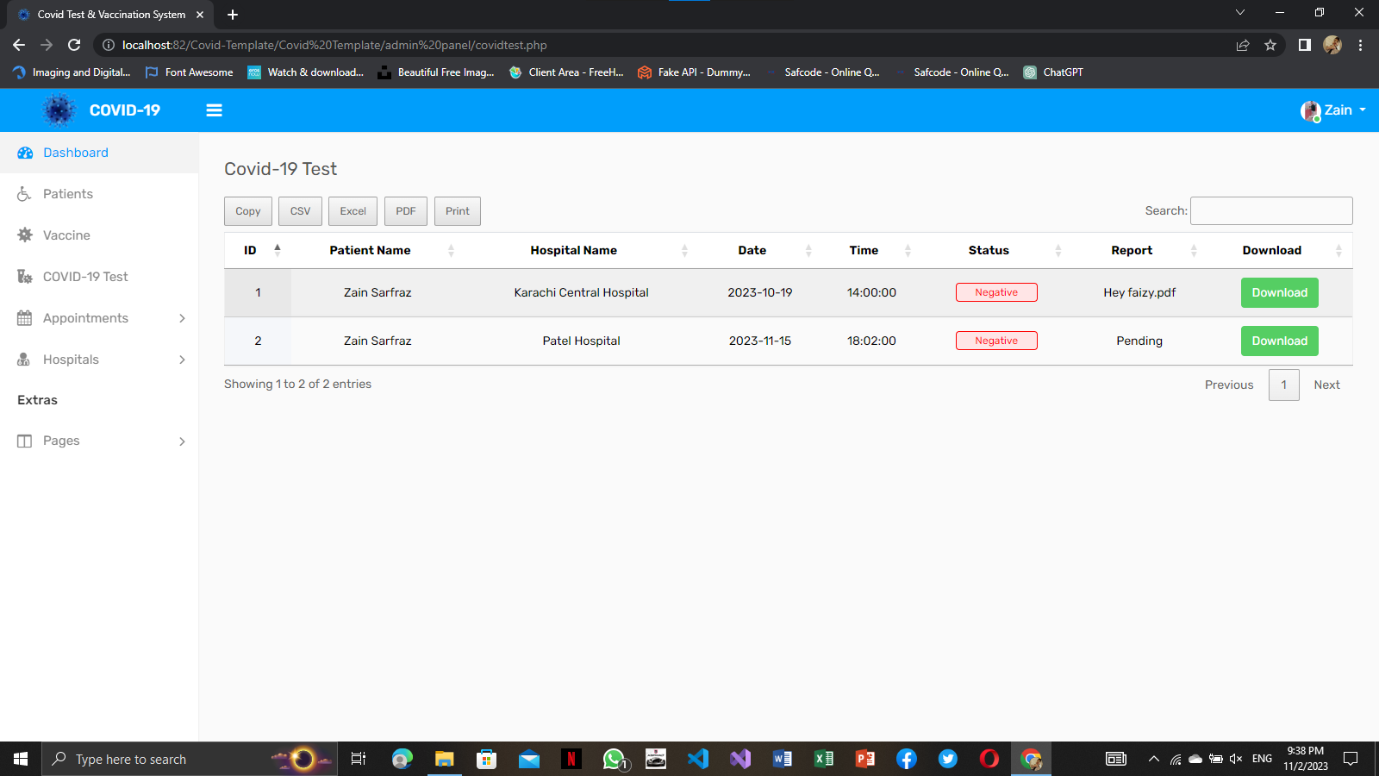

COVID TEST & VACCINATION SYSTEM

**VACCINE VIEW**

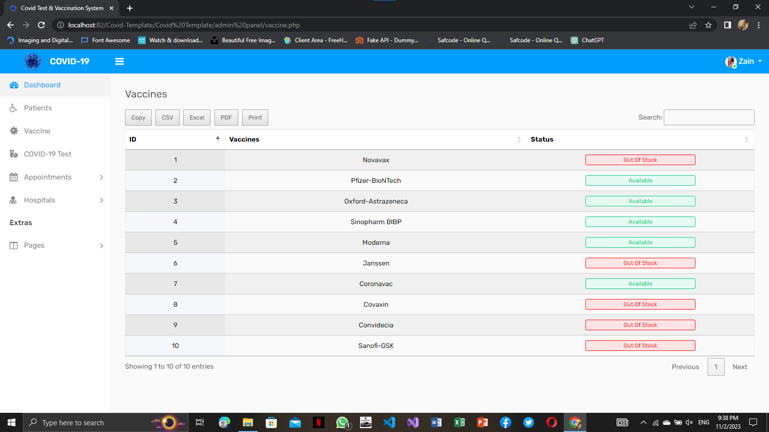

**PATIENTS VIEW**

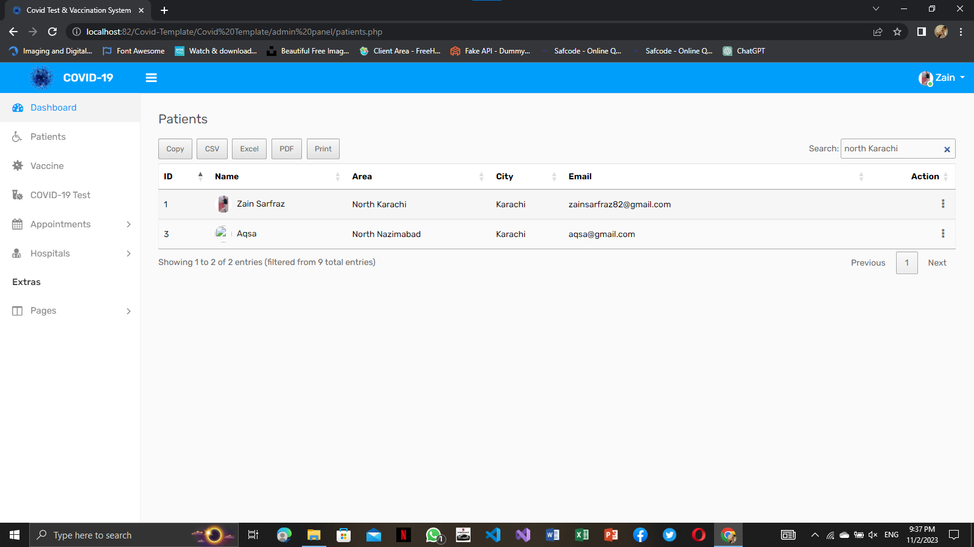

**HOSPITALS VIEW**

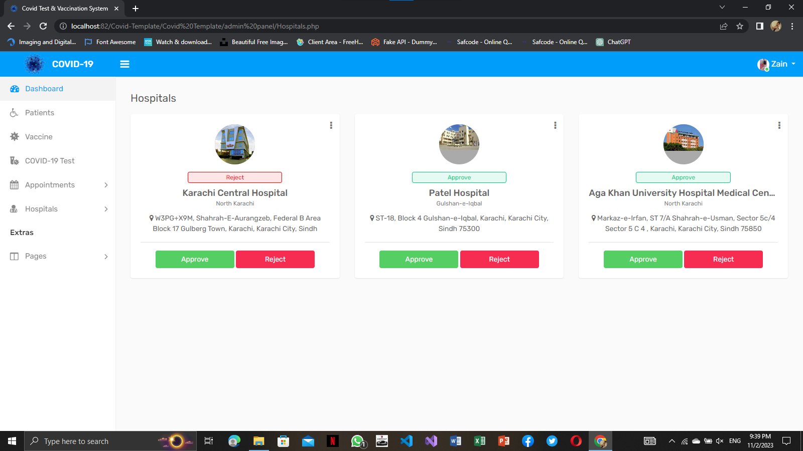

**APPOINTMENT VIEW**

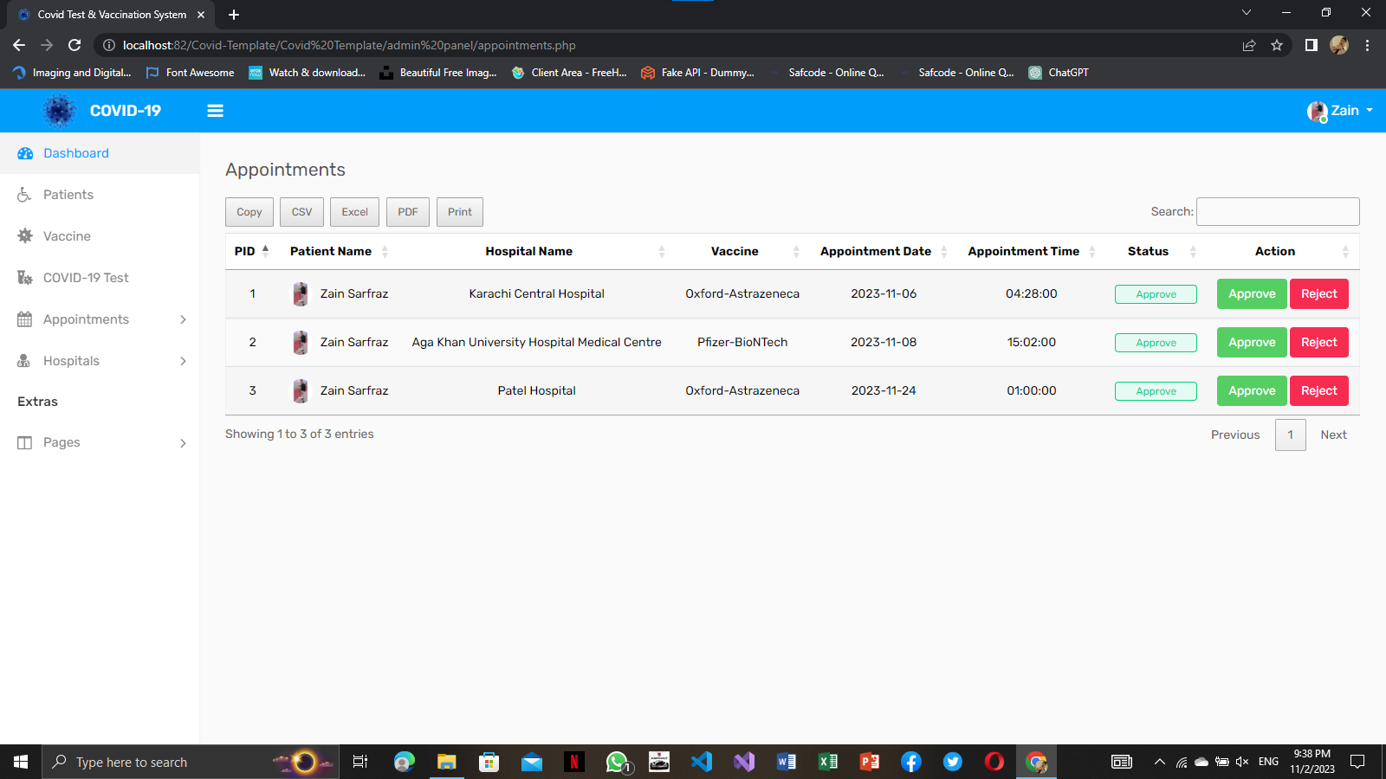

**APPROVE APPOINTMENT**

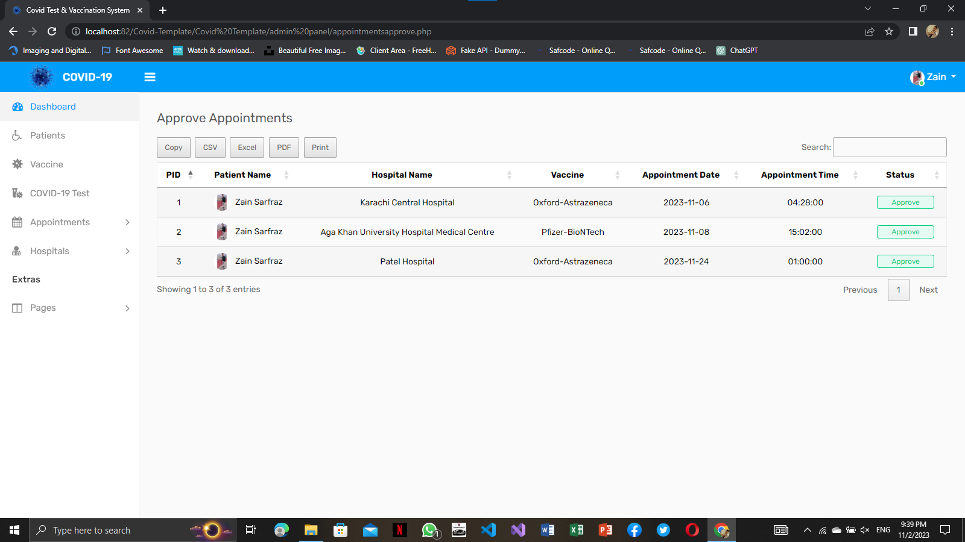

**APPROVE HOSPITAL**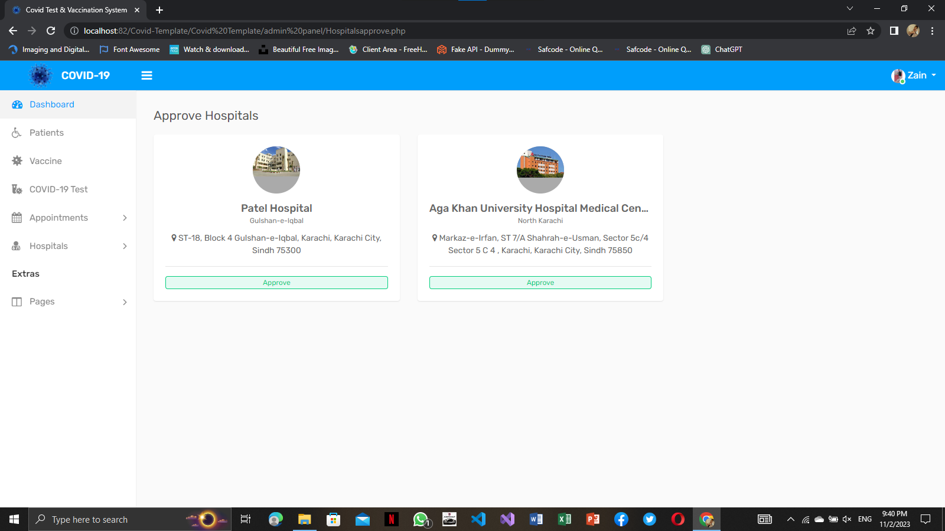

**REJECT APPOINTMENT**

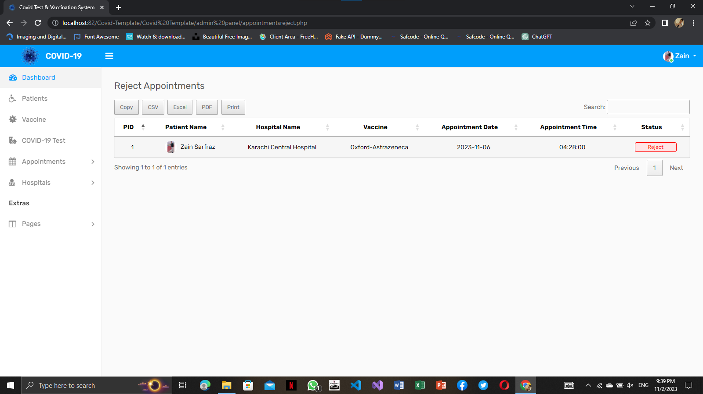

**REJECT HOSPITAL**

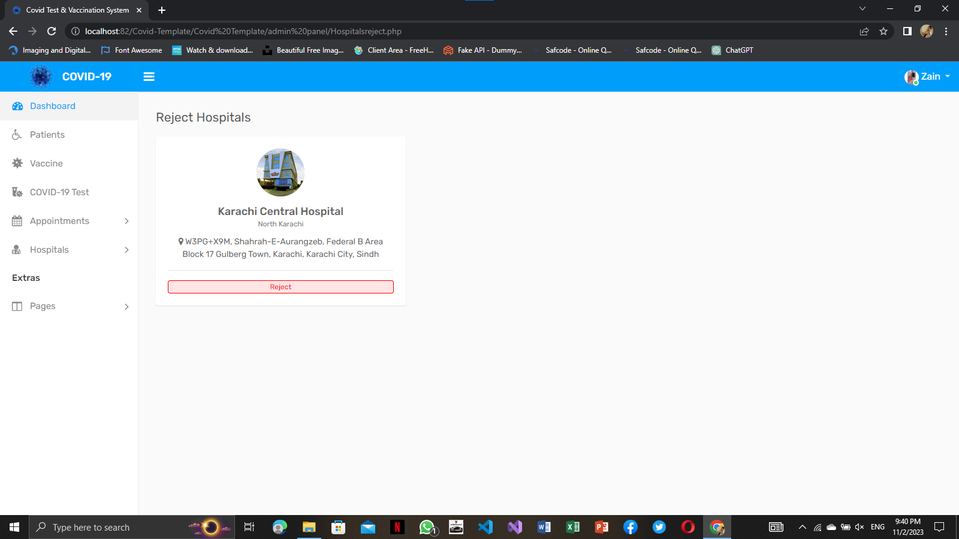

**PATIENT**

**SCREENSHOTS**

**HEADER**



**FOOTER**

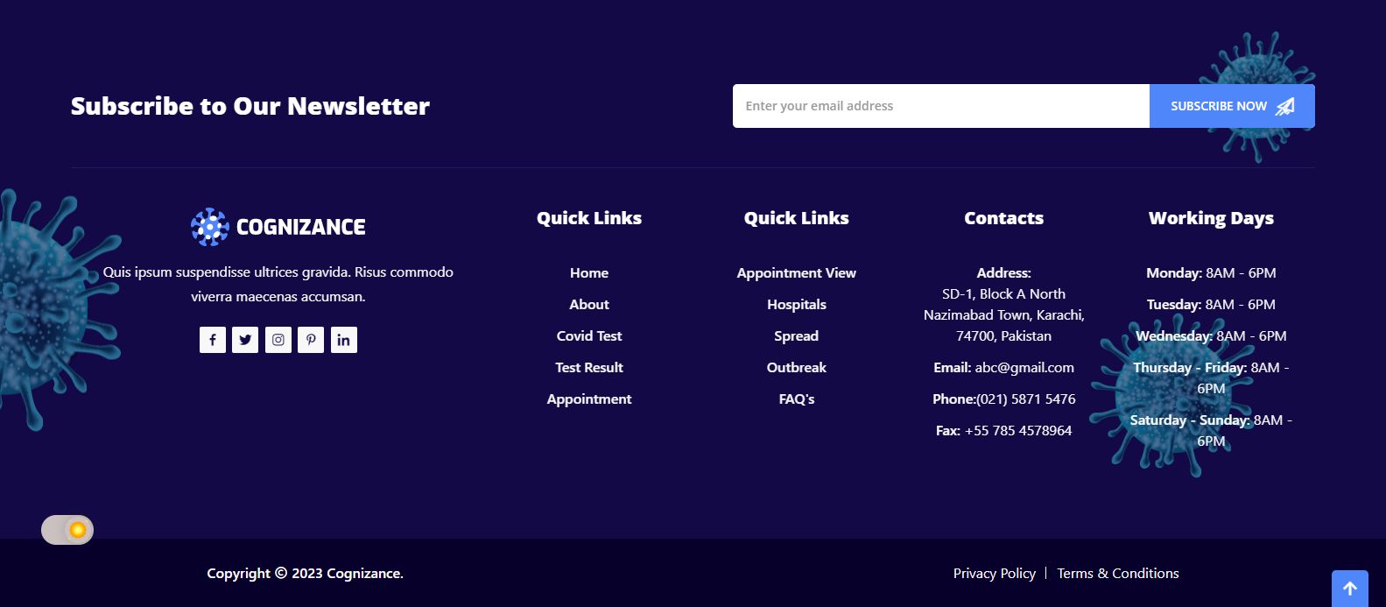

**LOGIN**

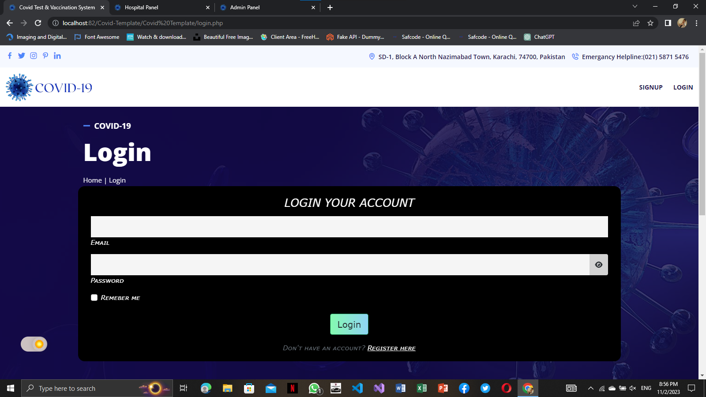

**REGISTER**

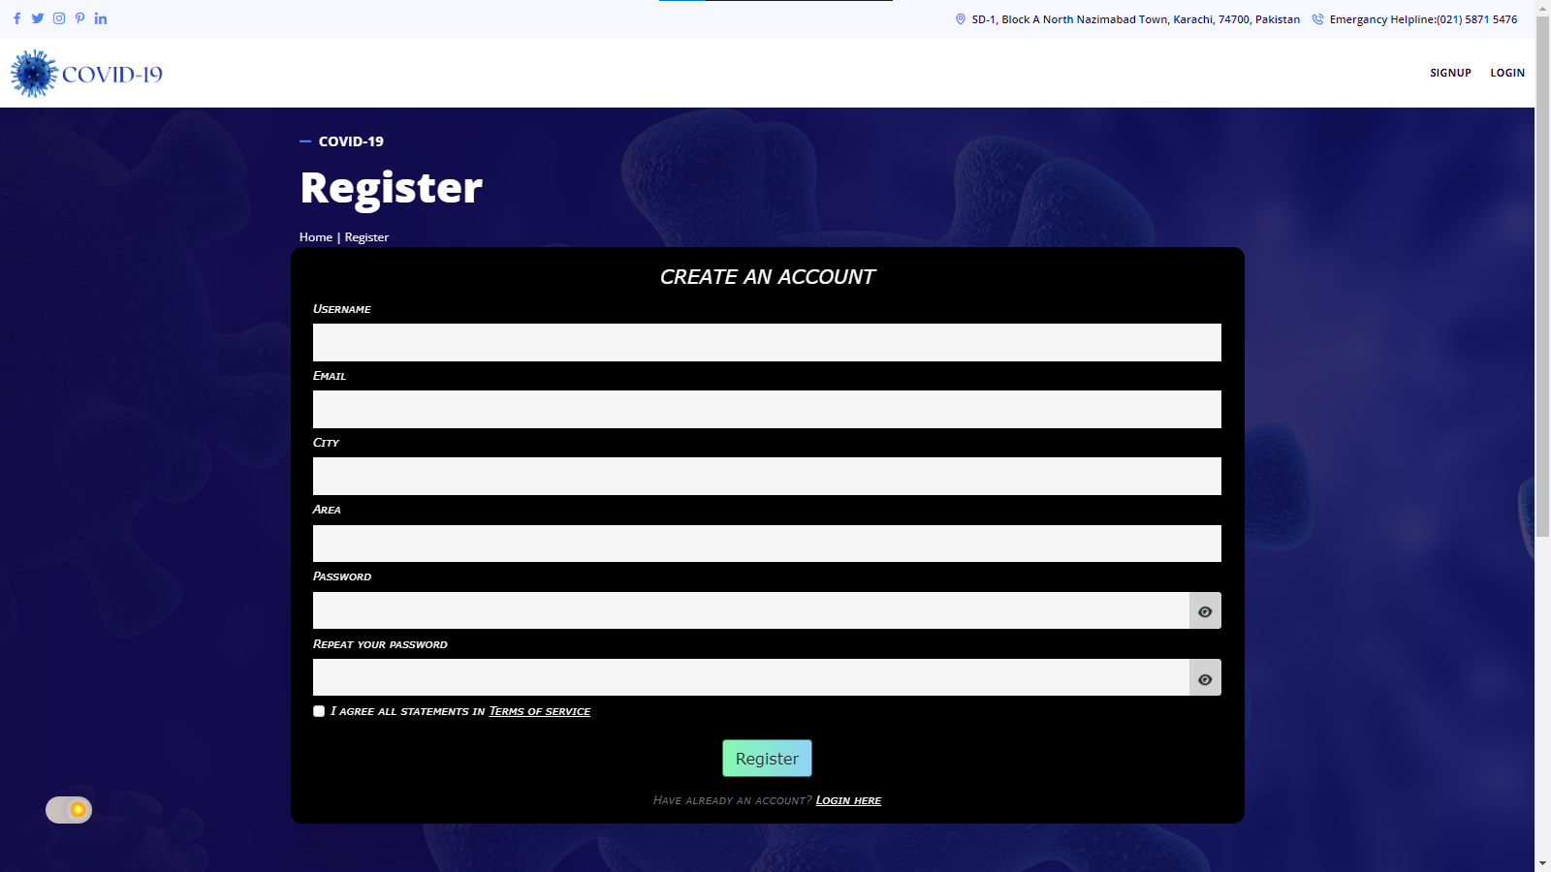

**CHANGE PASSWORD**

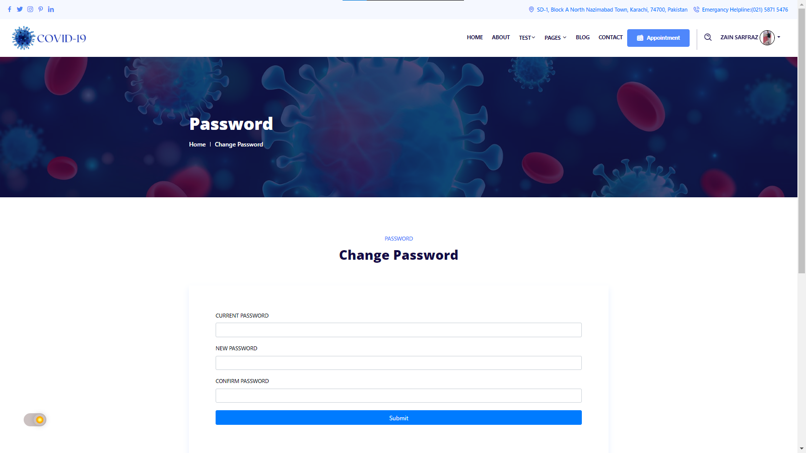

**HOME**

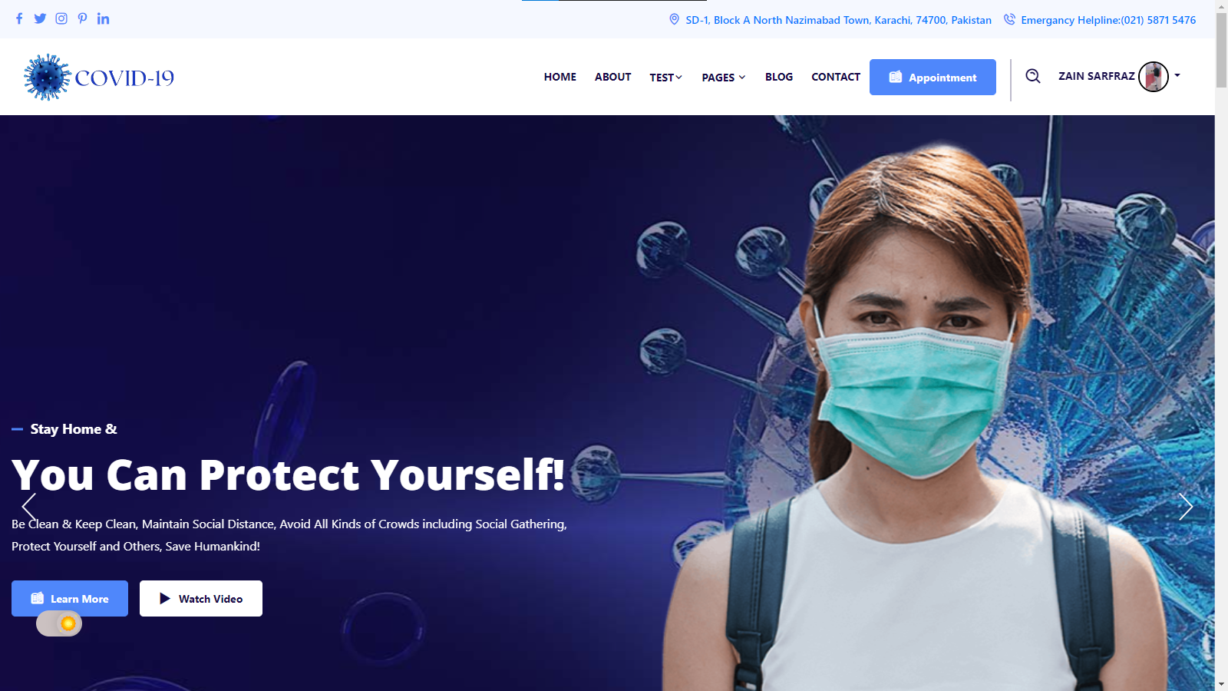

**ABOUT US**

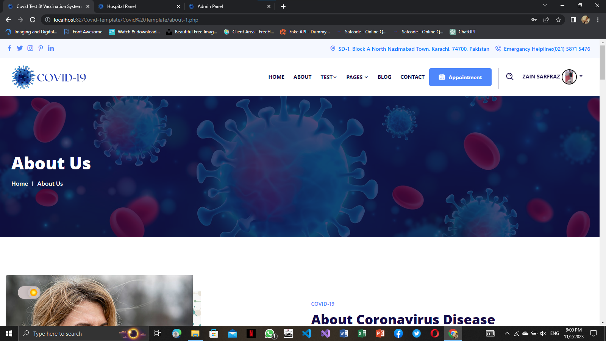

**CONTACT US**

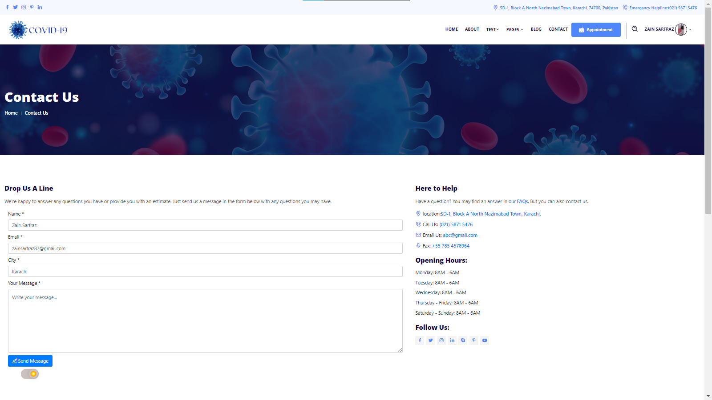

**BLOG**

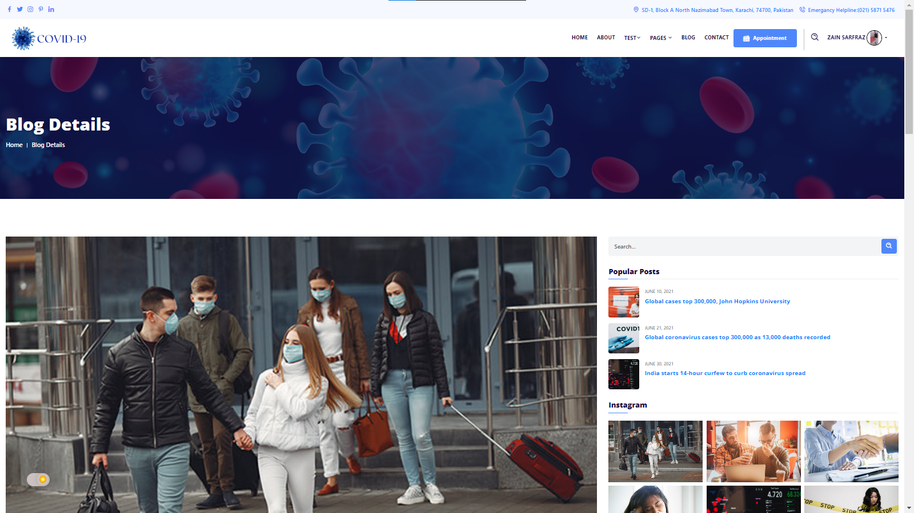

**OUT-BREAK**

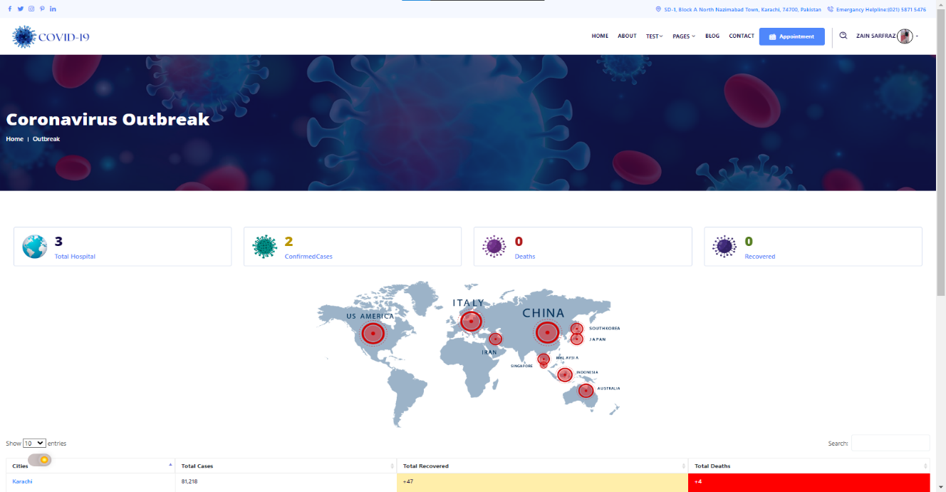

**SPREAD**

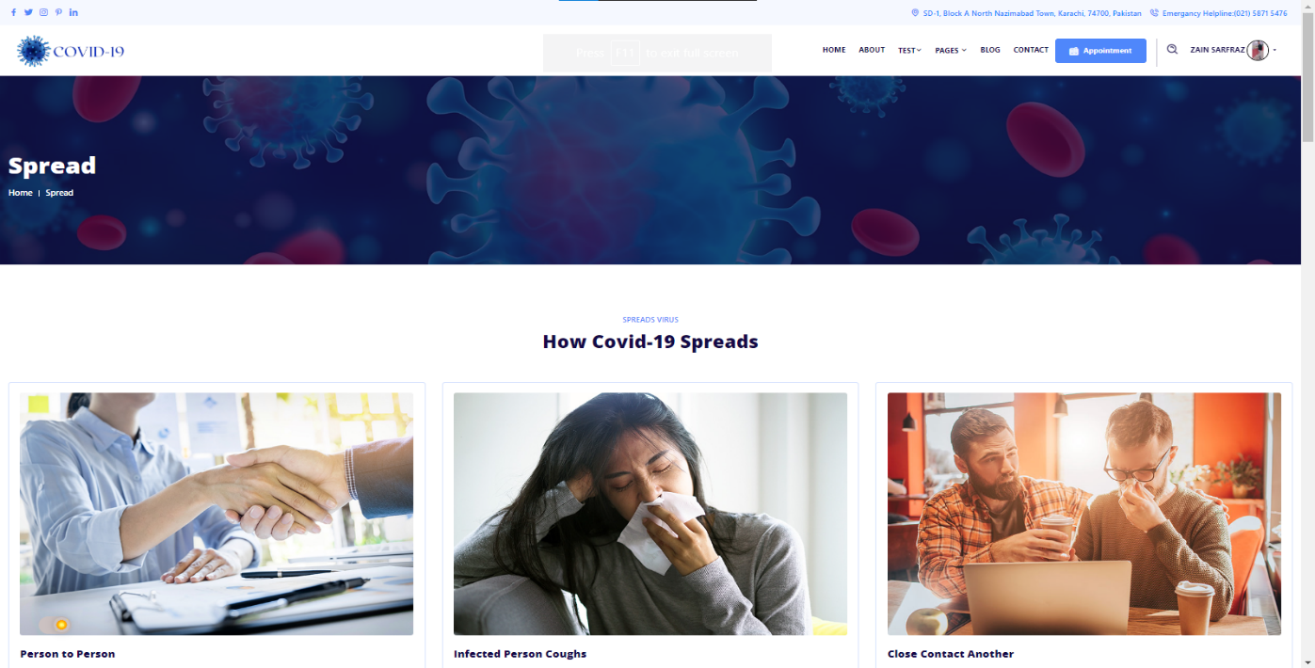

**FAQ**

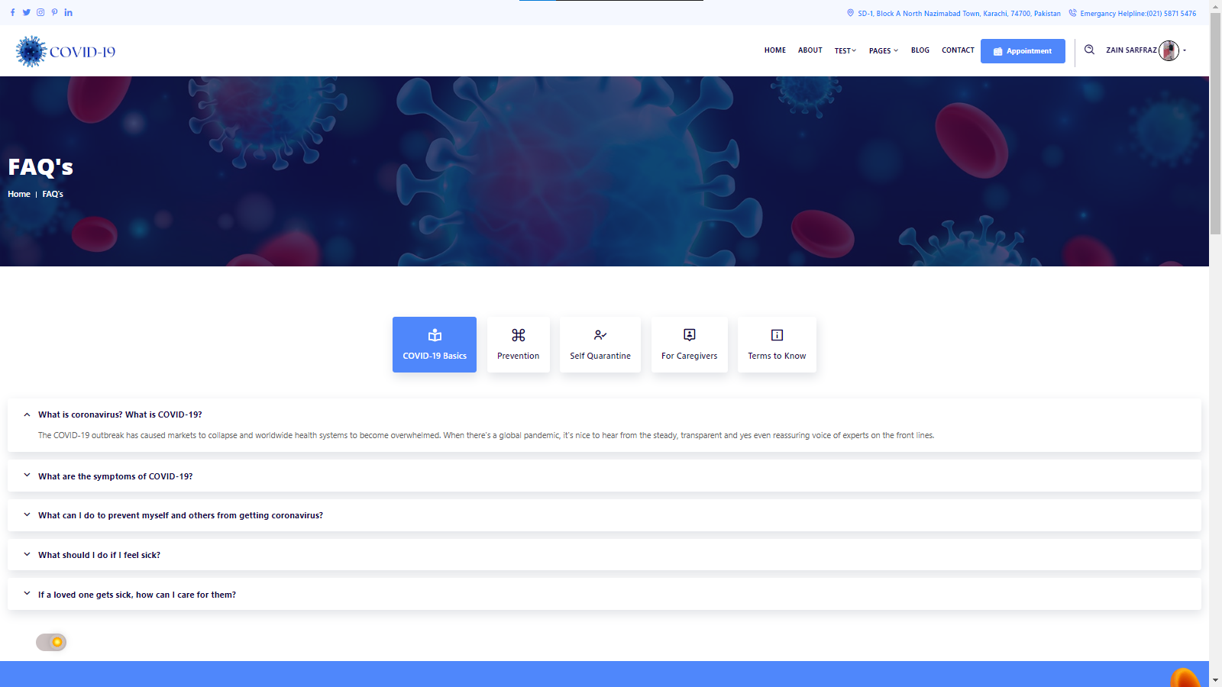

**SEARCH BAR**

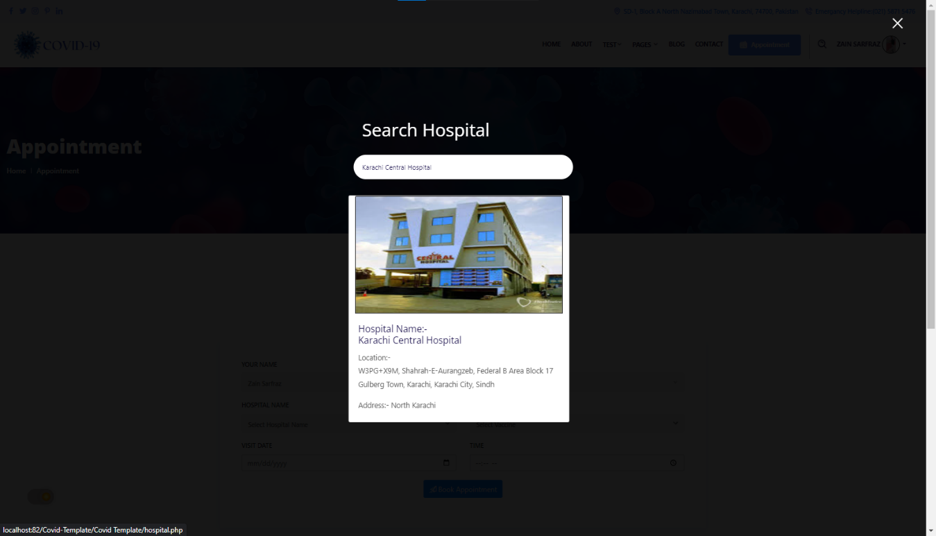

**HOSPITAL**

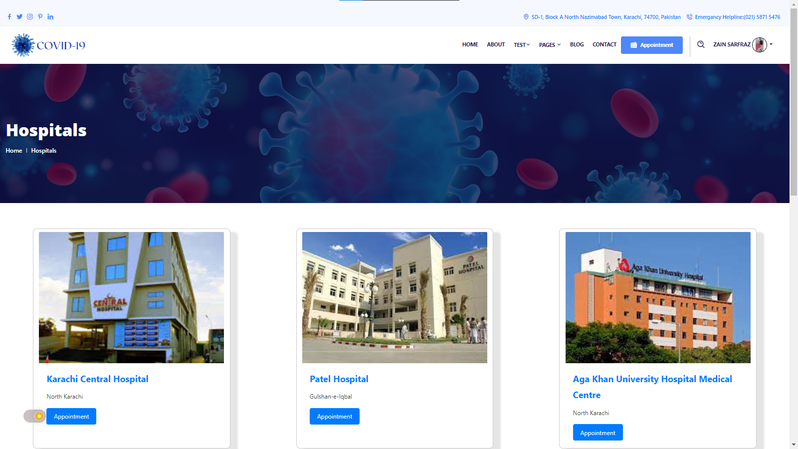

**USER PROFILE**

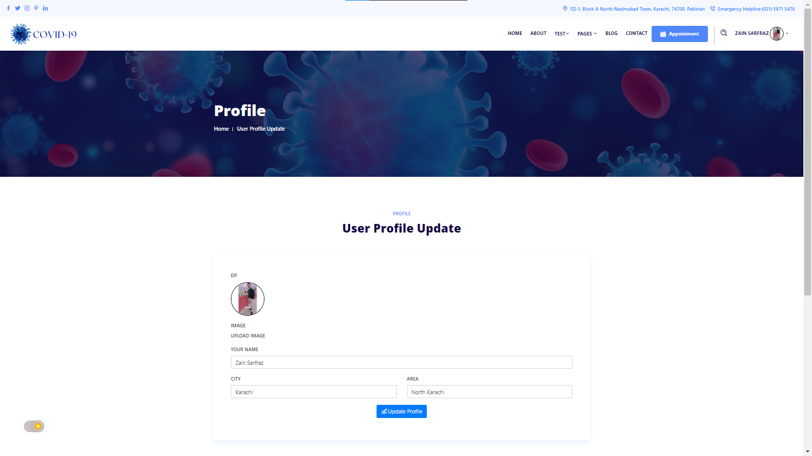

**VIEW RESULT**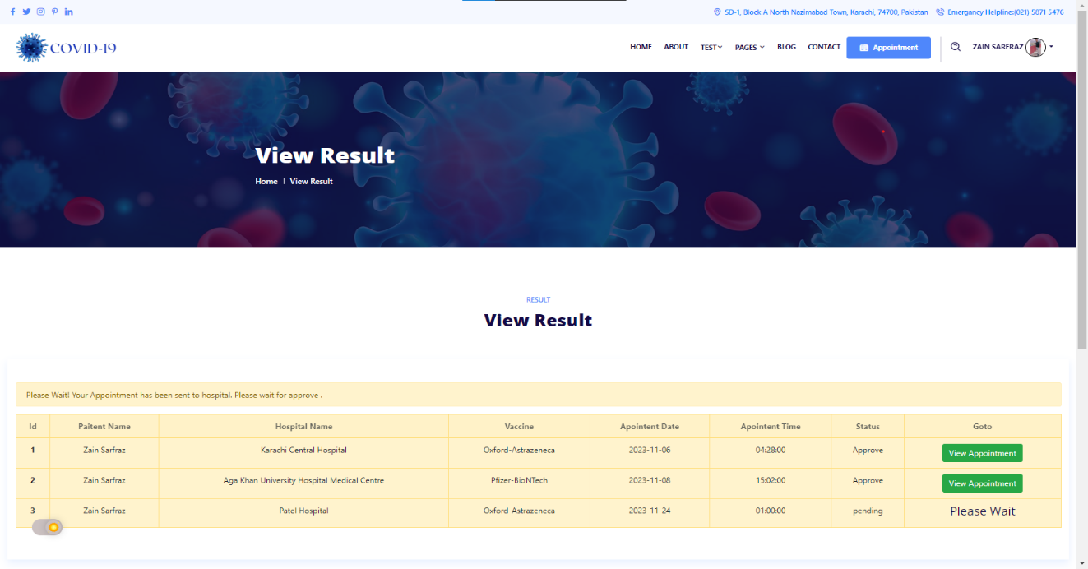

**COVID TEST 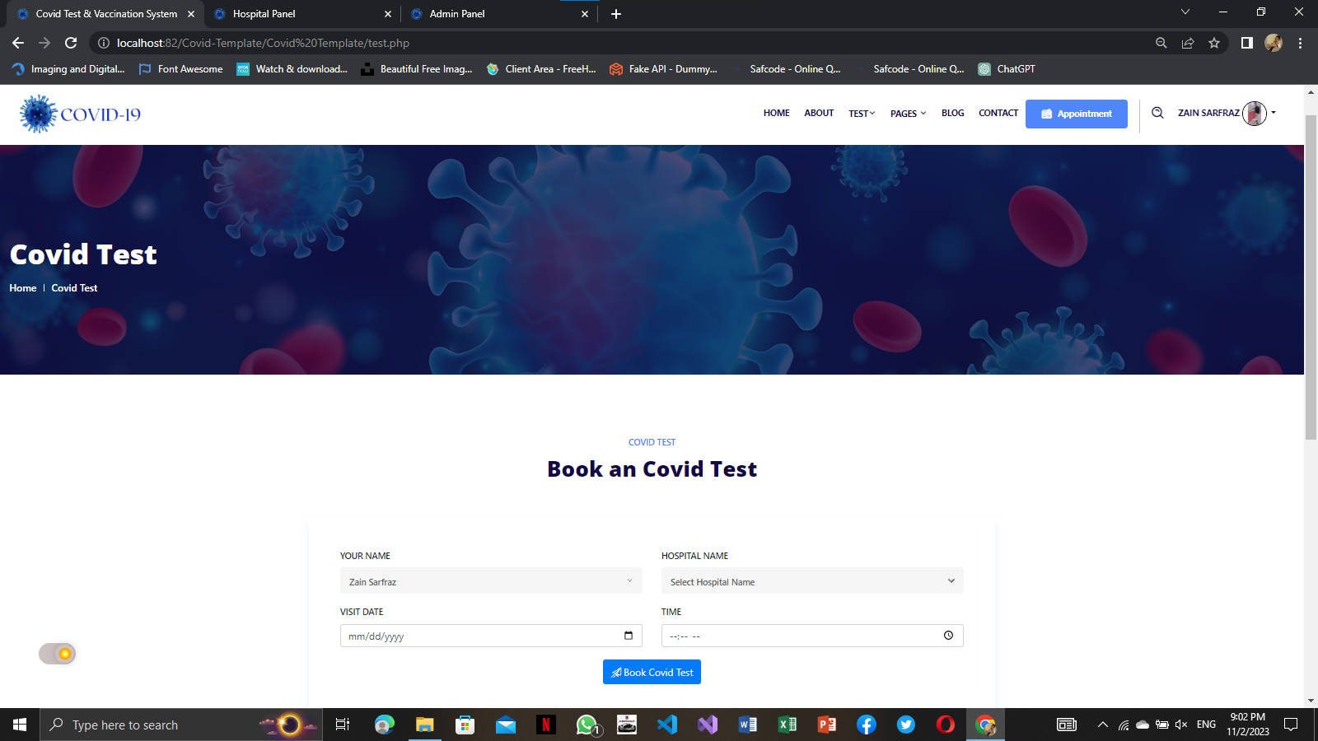COVID TEST VIEW**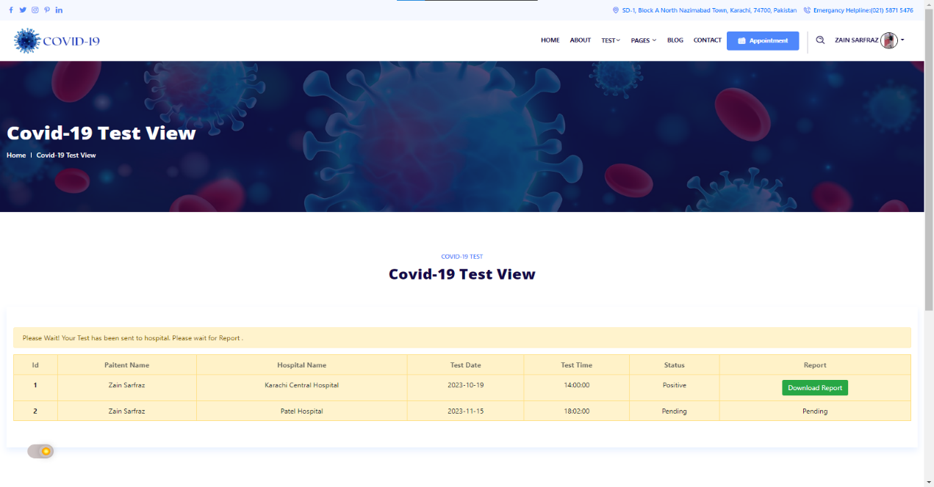

**APPOINTMENT**

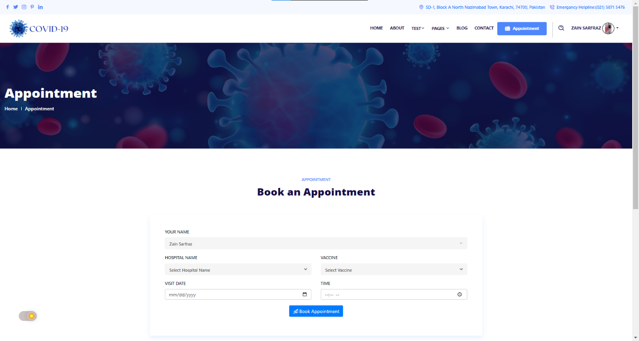**APPOINTMENT VIEW**

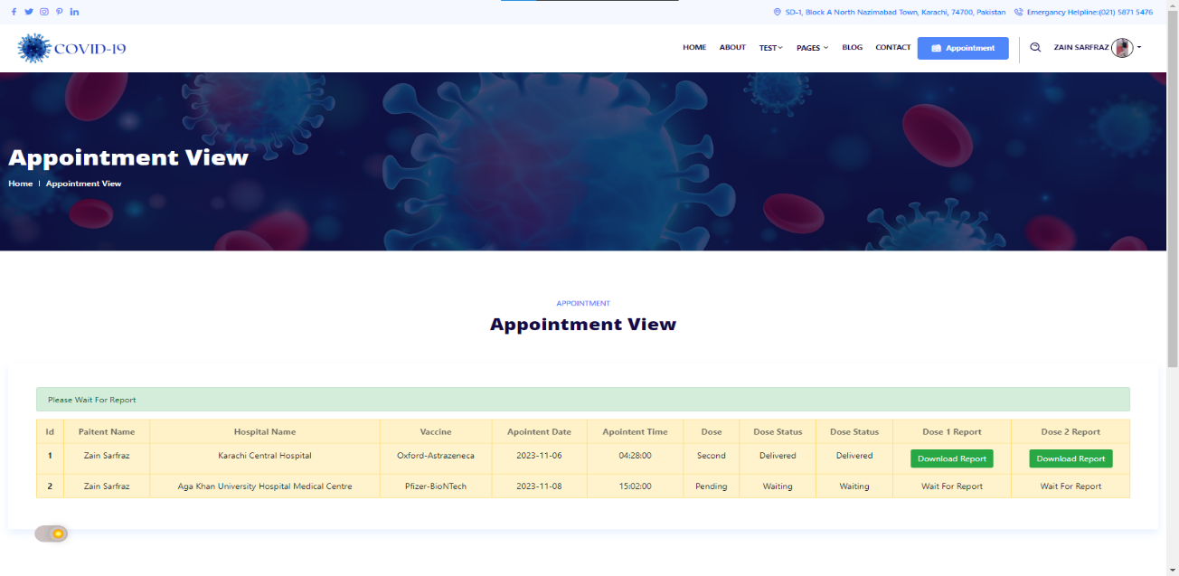

**HOSPITAL**

**SCREENSHOTS**

**HEADER**



**FOOTER**



**LOGIN**

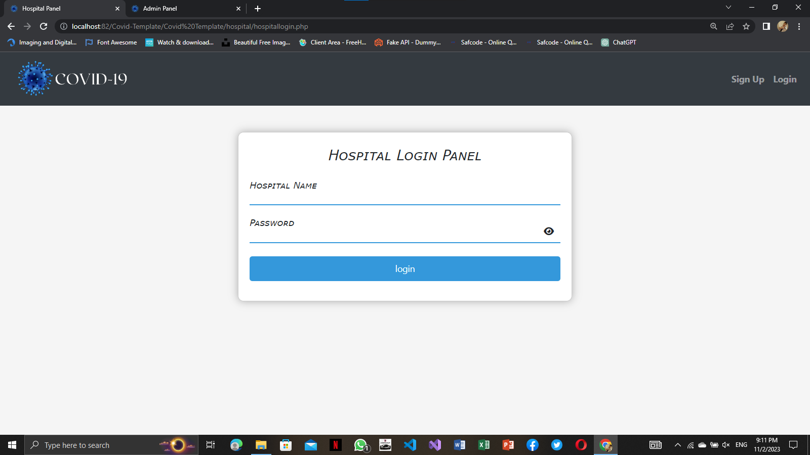

**REGISTER**

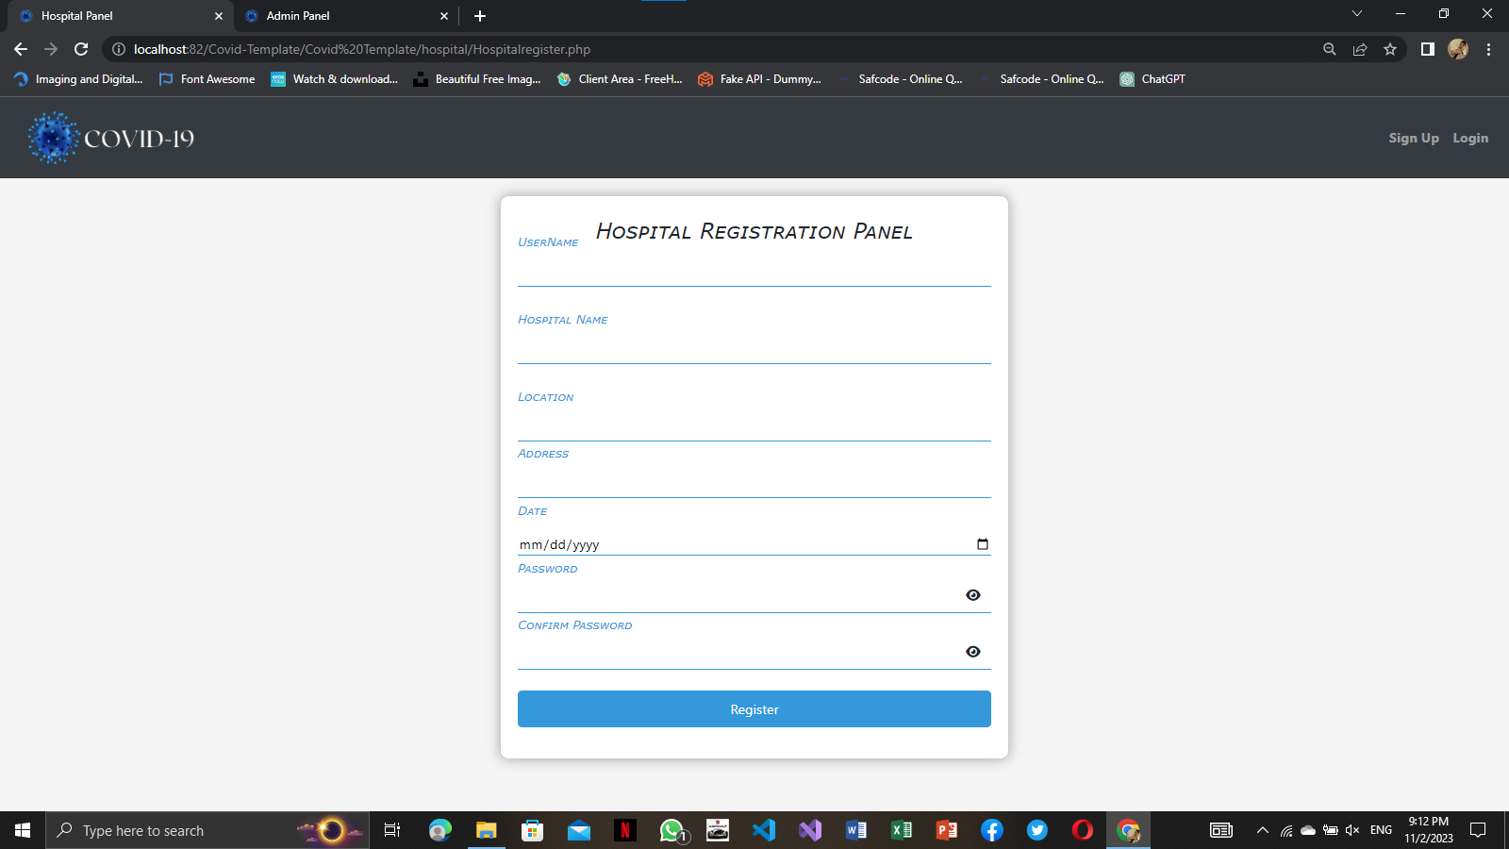

**PROFILE**

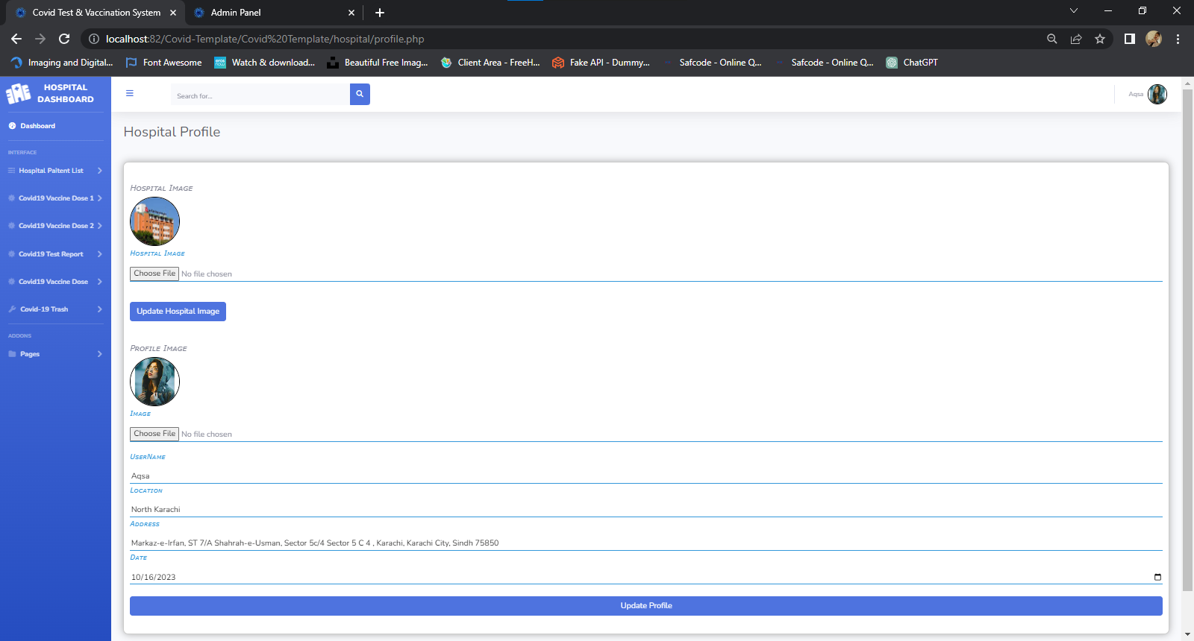

**HOME**

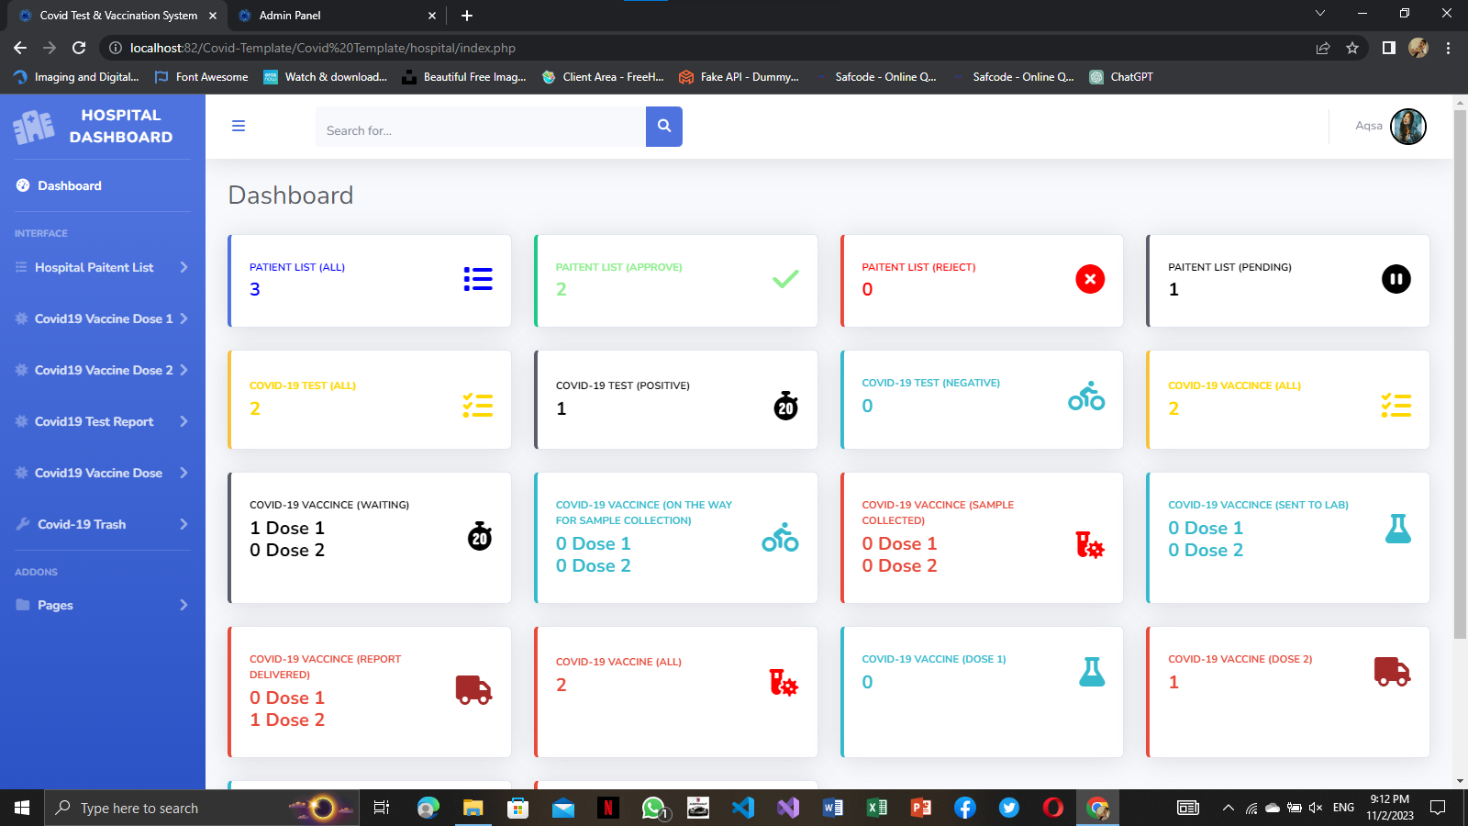

**SIDEBAR**

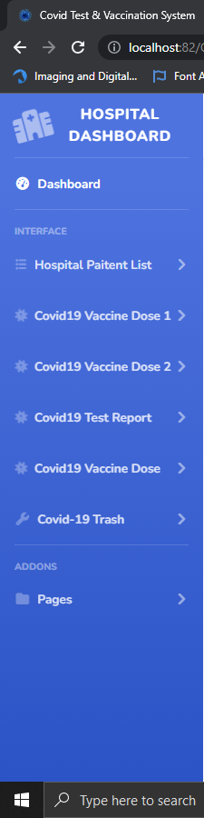

**CHANGE PASSWORD**

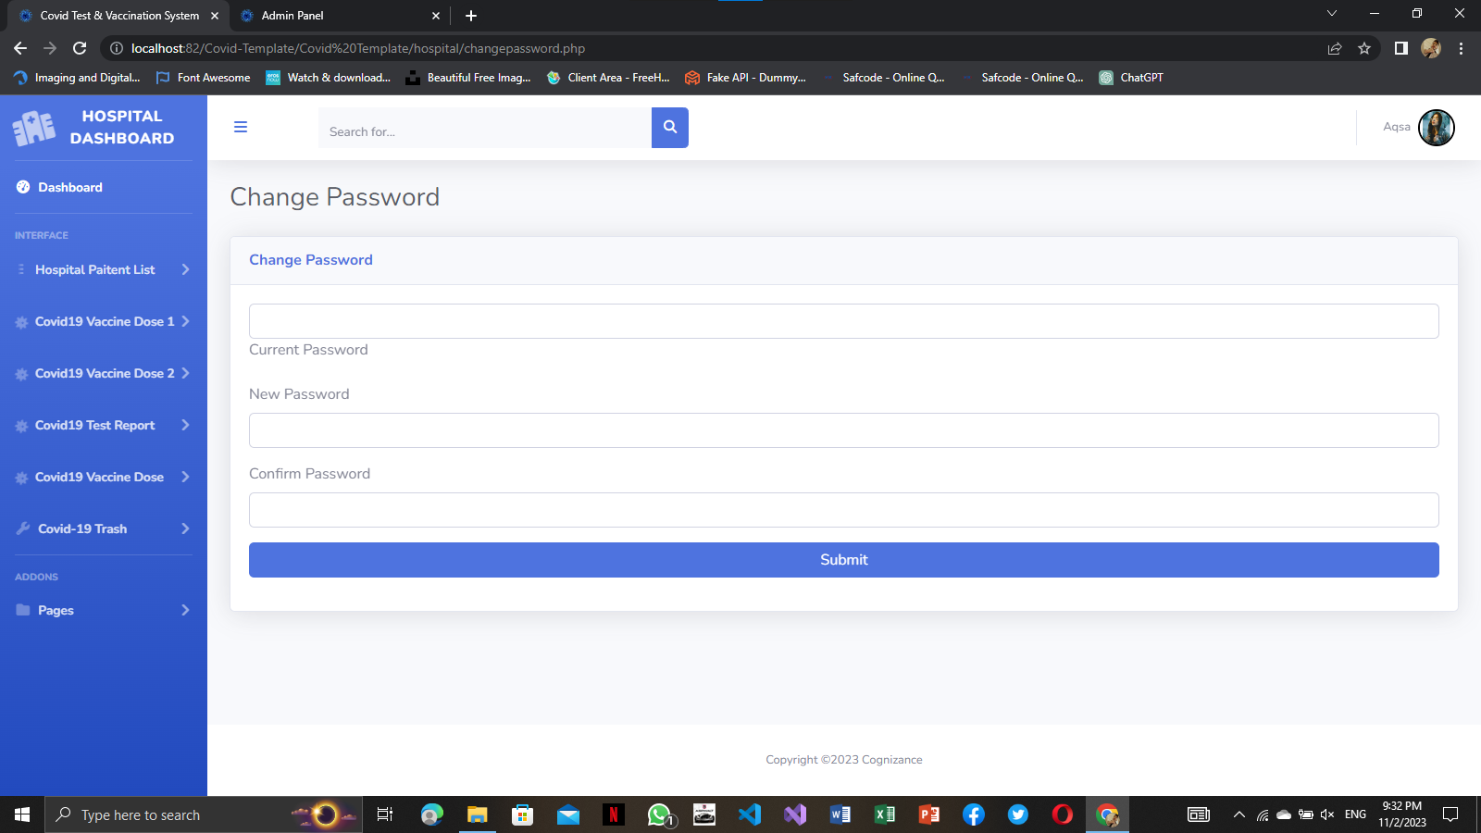

**POSITIVE**

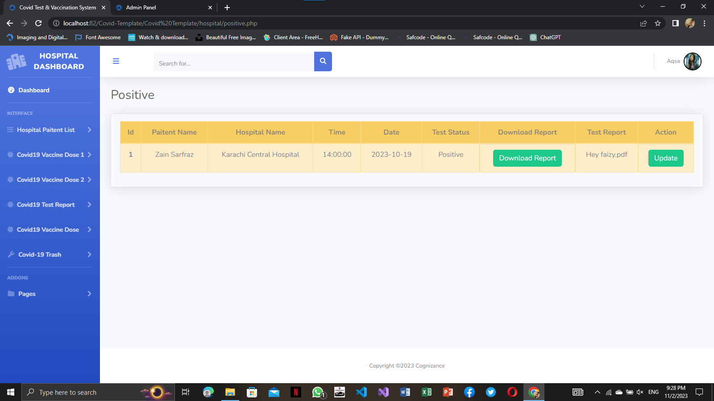

**NEGATIVE**

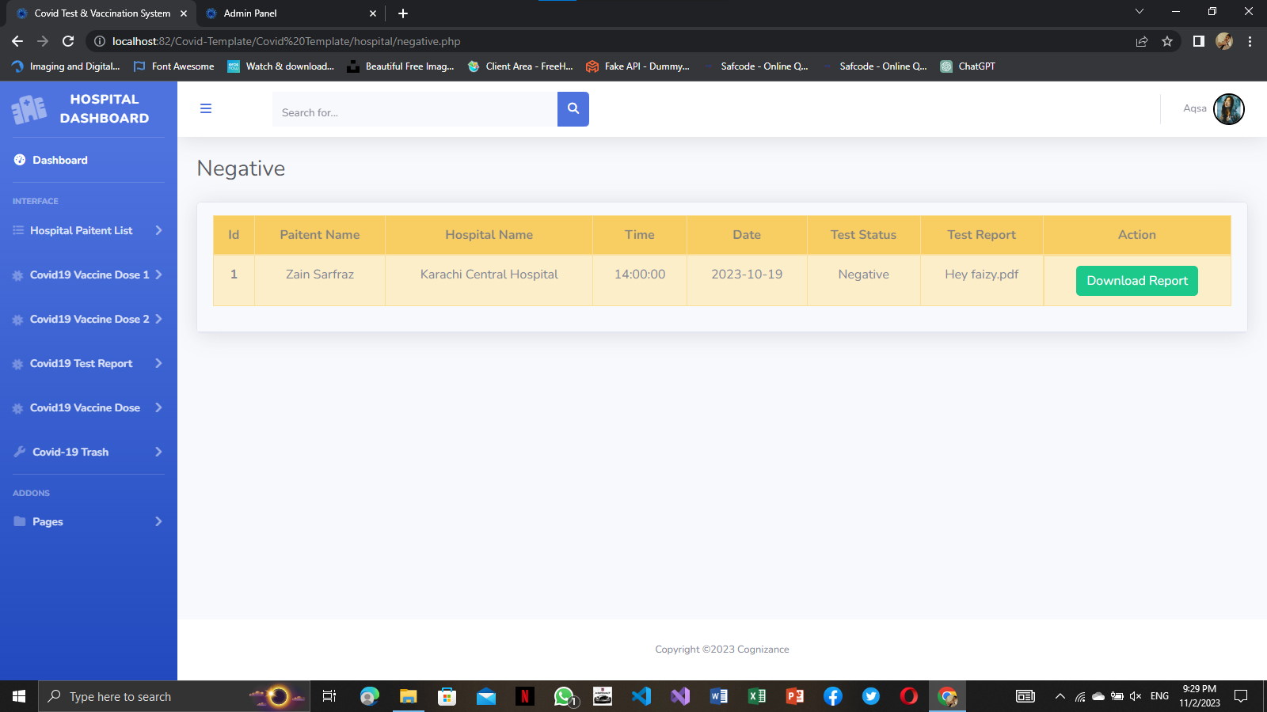

**COVID TEST**

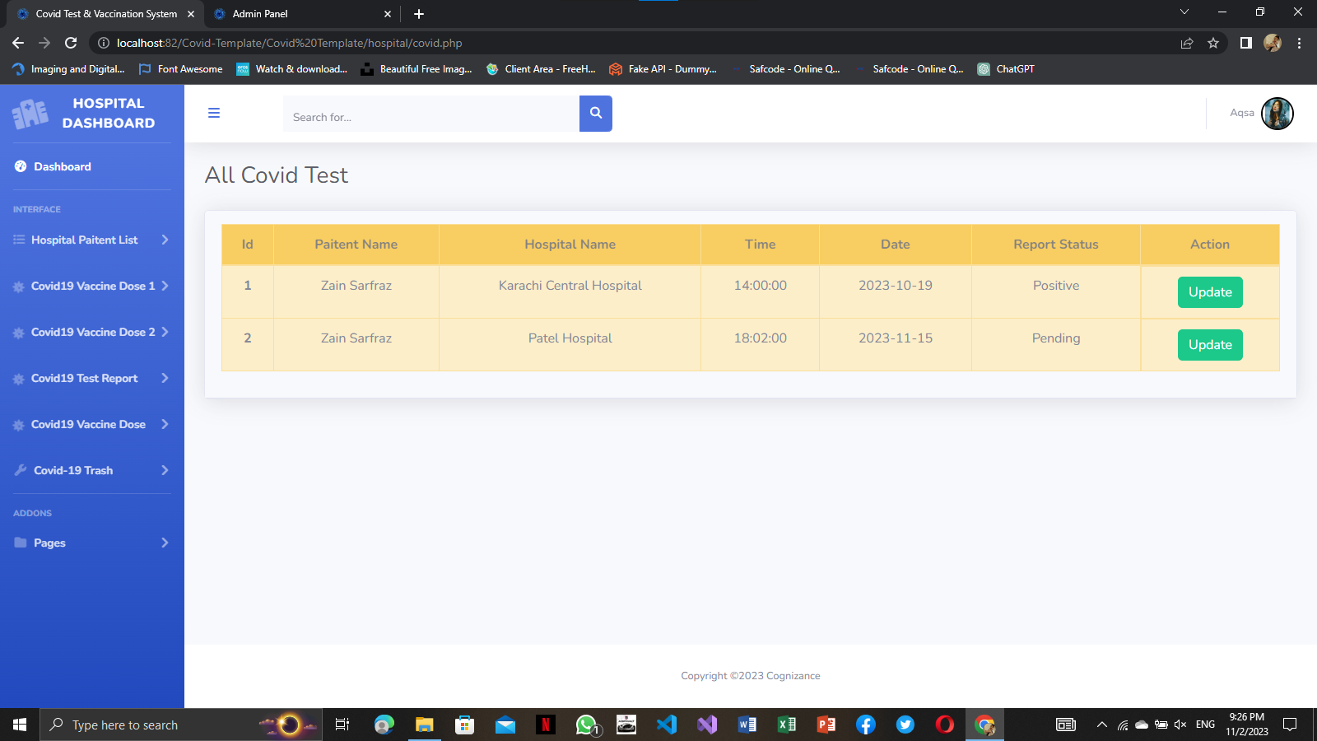

**COVID TEST UPDATE**

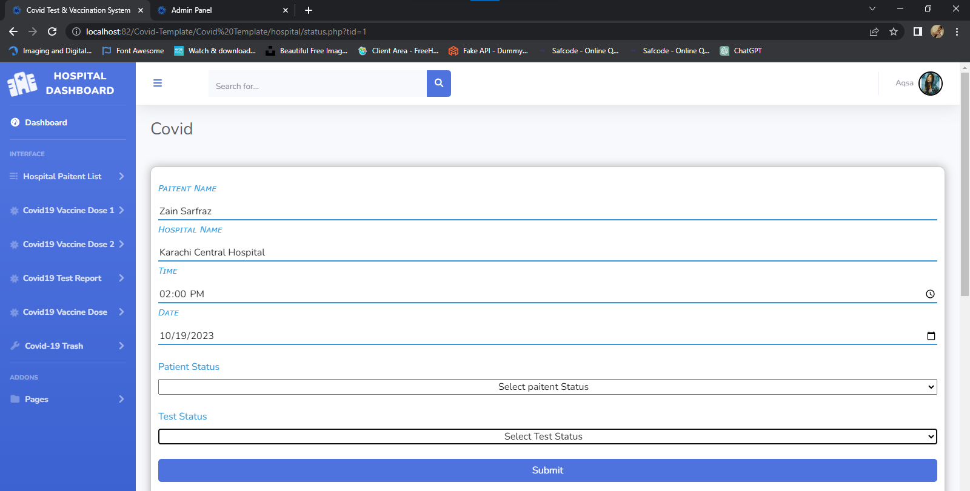

**TRASH DATA**

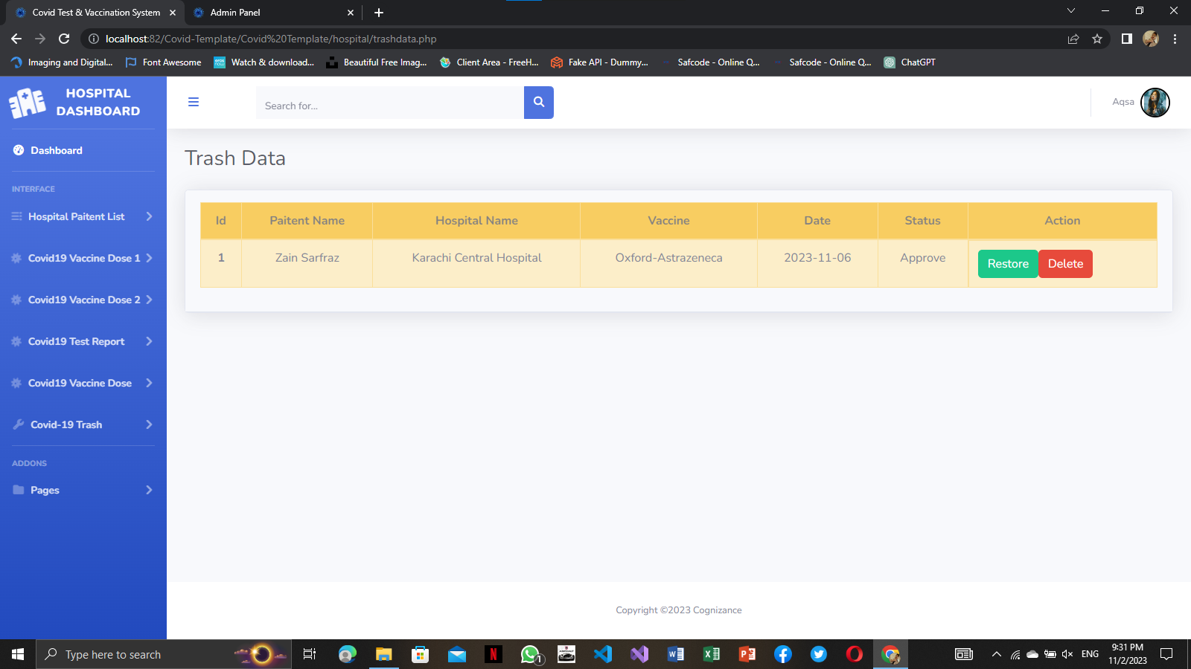

**FIRST DOSE**

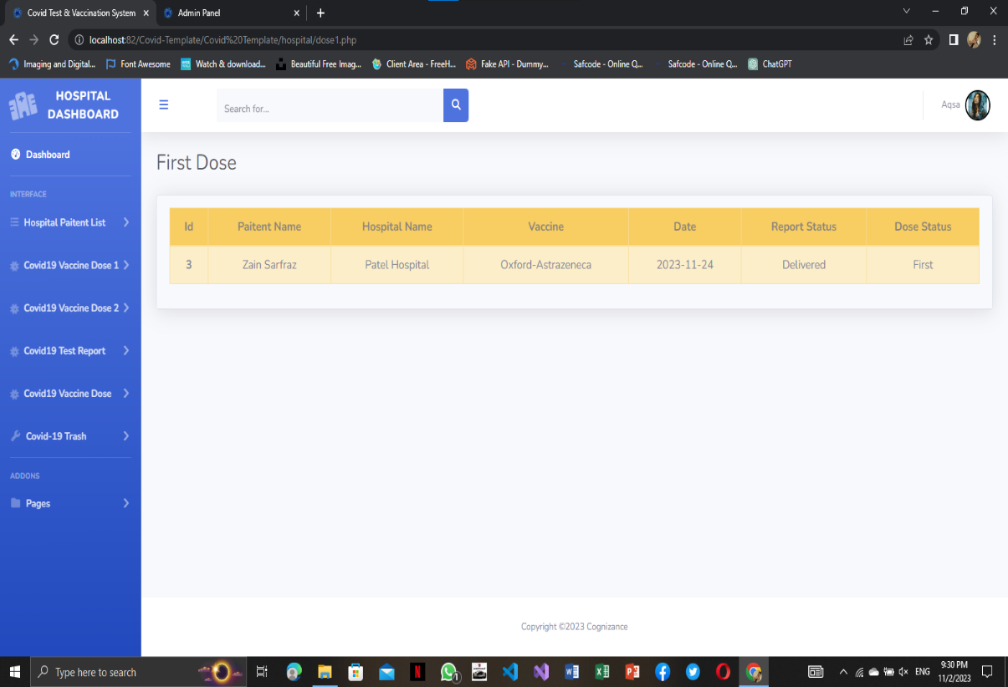

**DOSE 1 WAITING REPORT**

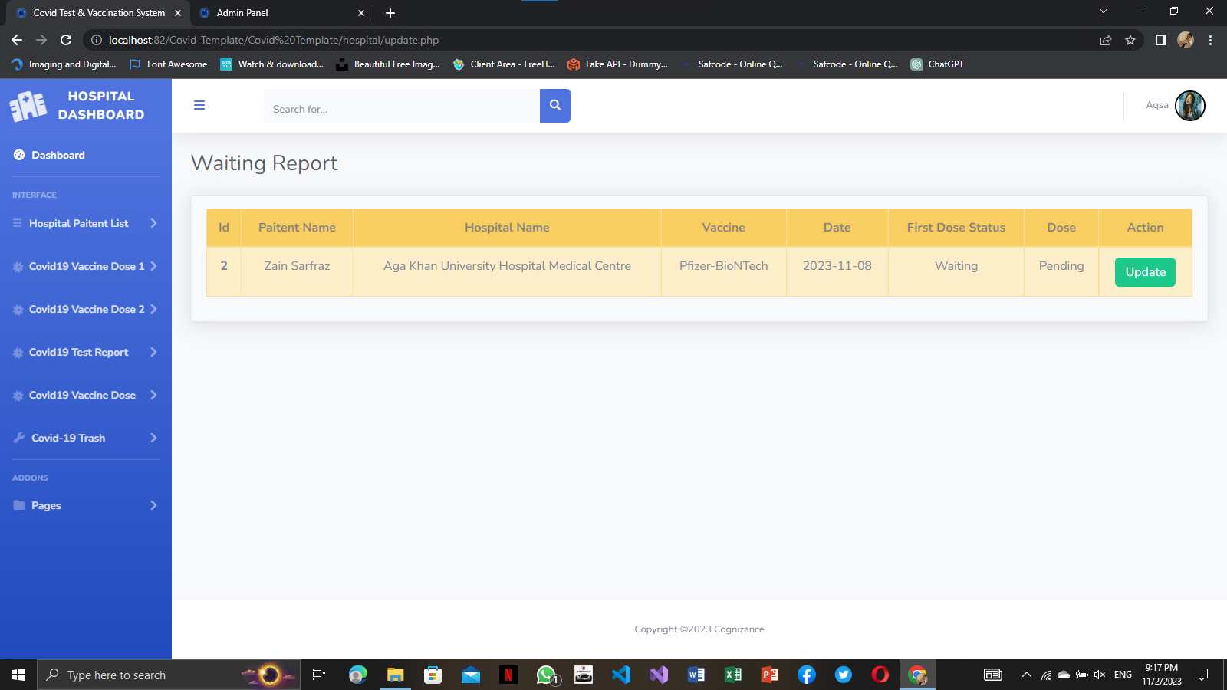

**DOSE 1 REPORT DELIVERED**

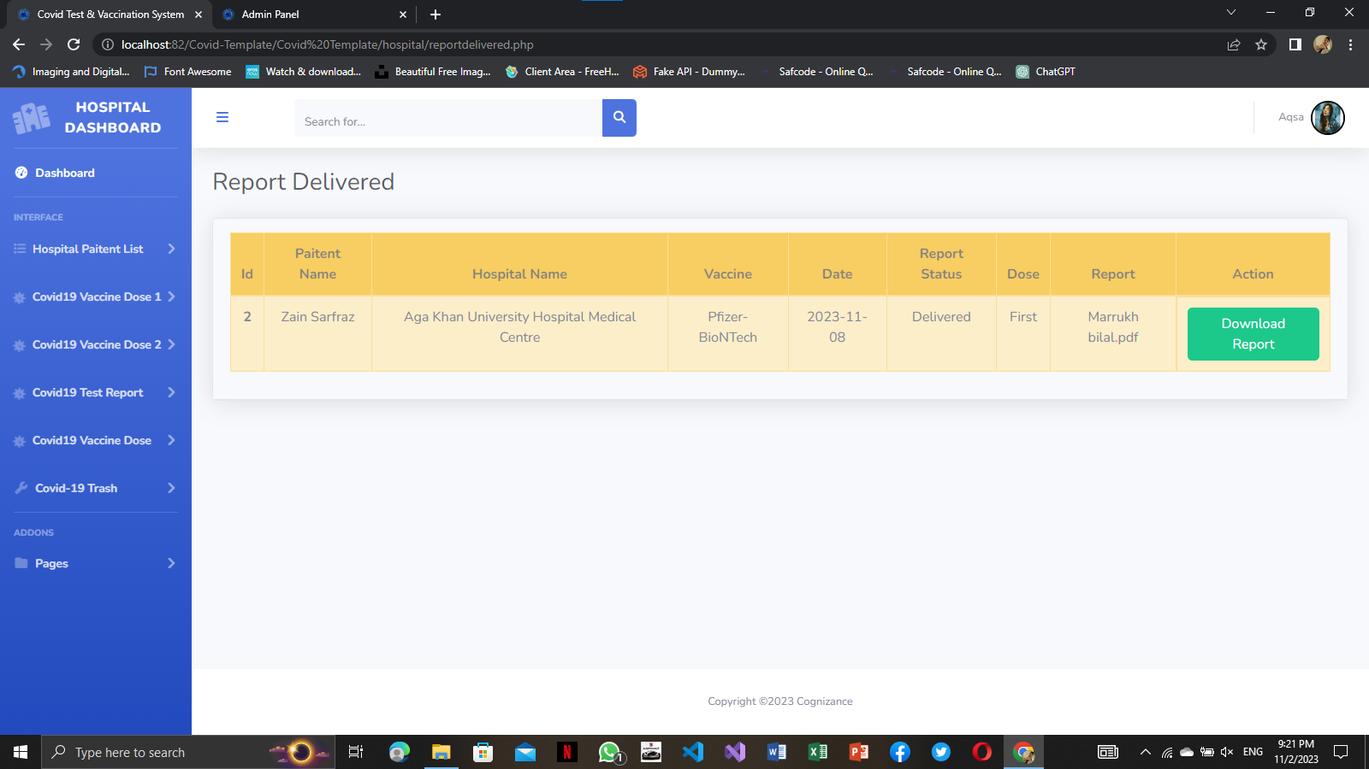

**DOSE 2 SAMPLE COLLECTED**

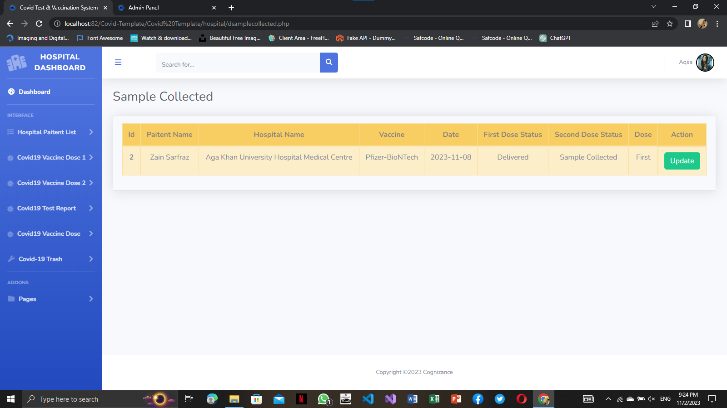

**DOSE 2 SENT TO LAB**

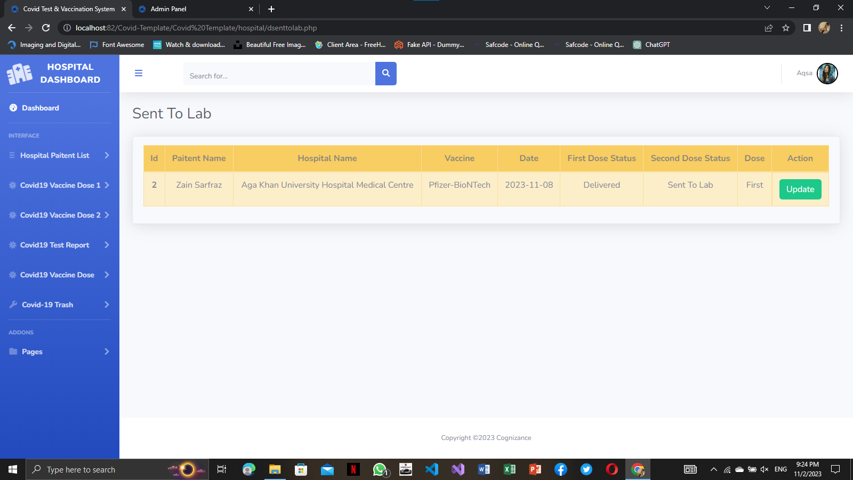

**DOSE 2 SENT TO LAB UPDATE**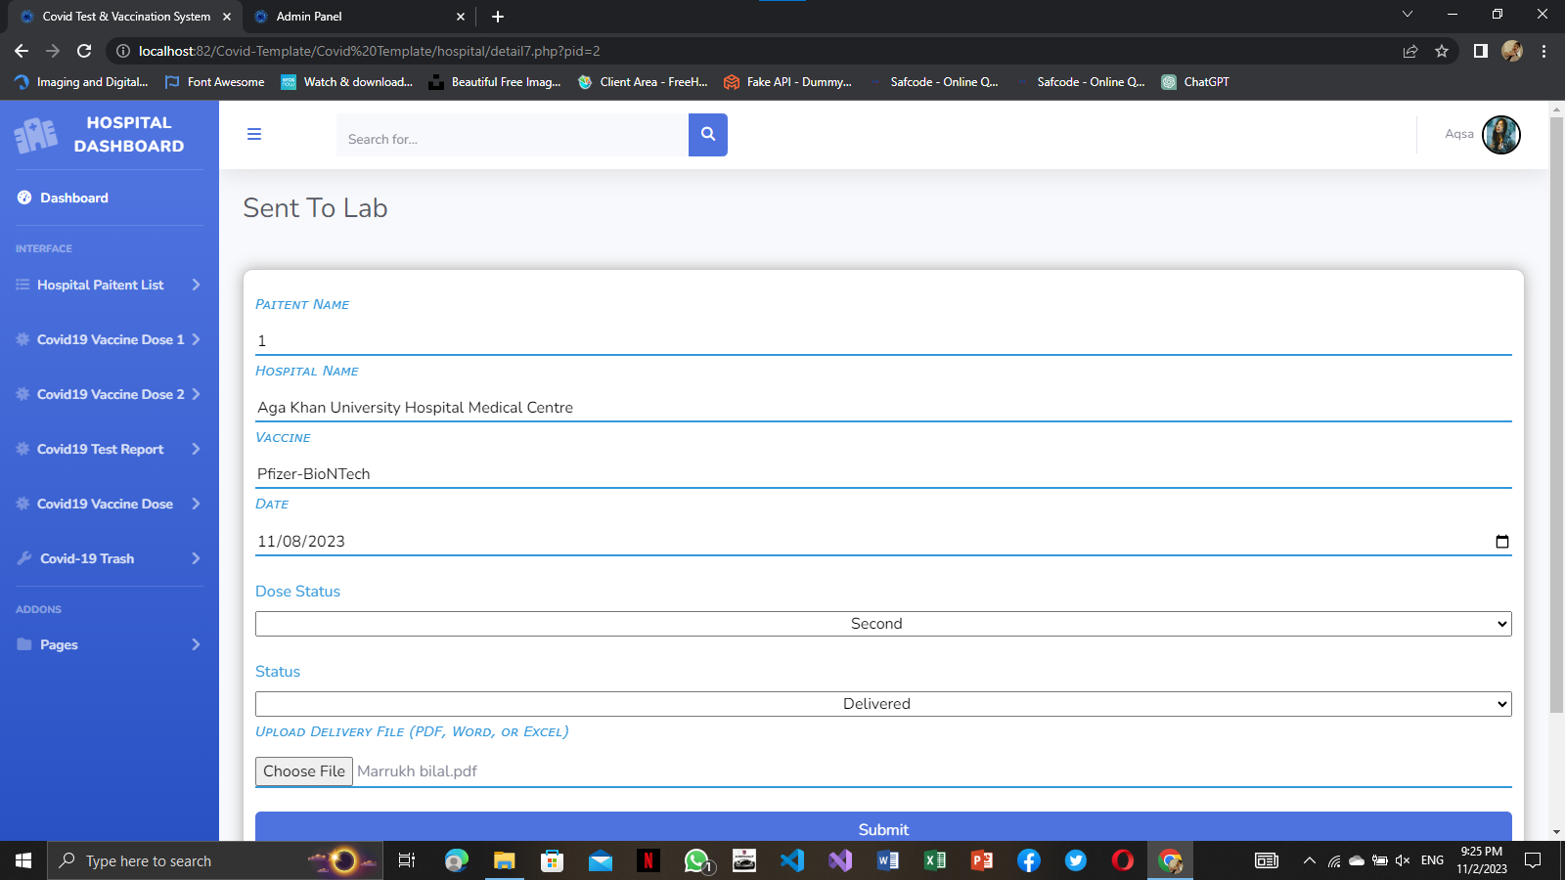

**DOSE 2 ON THE WAY**

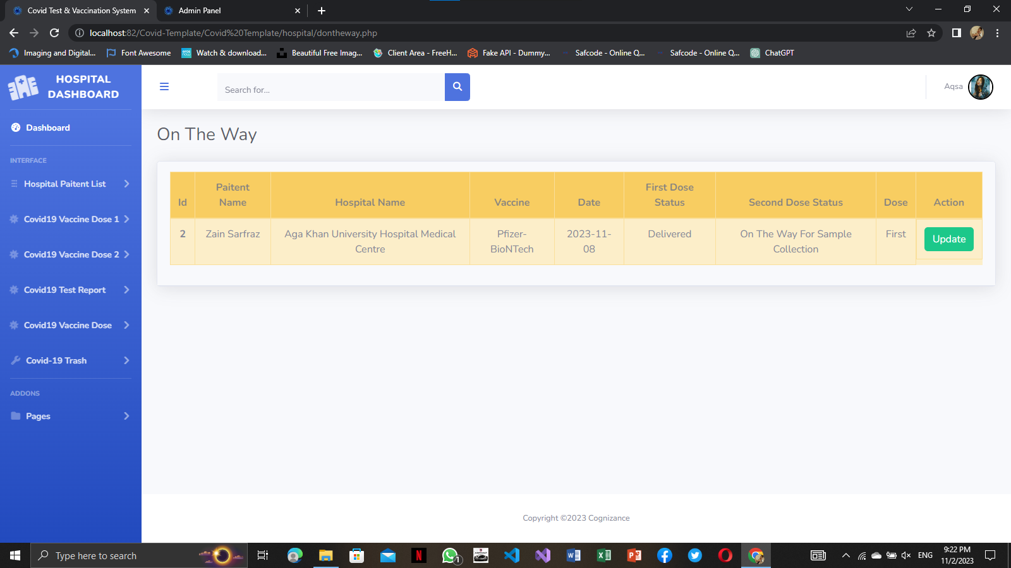

**DOSE 2 ON THE WAY UPDATE**

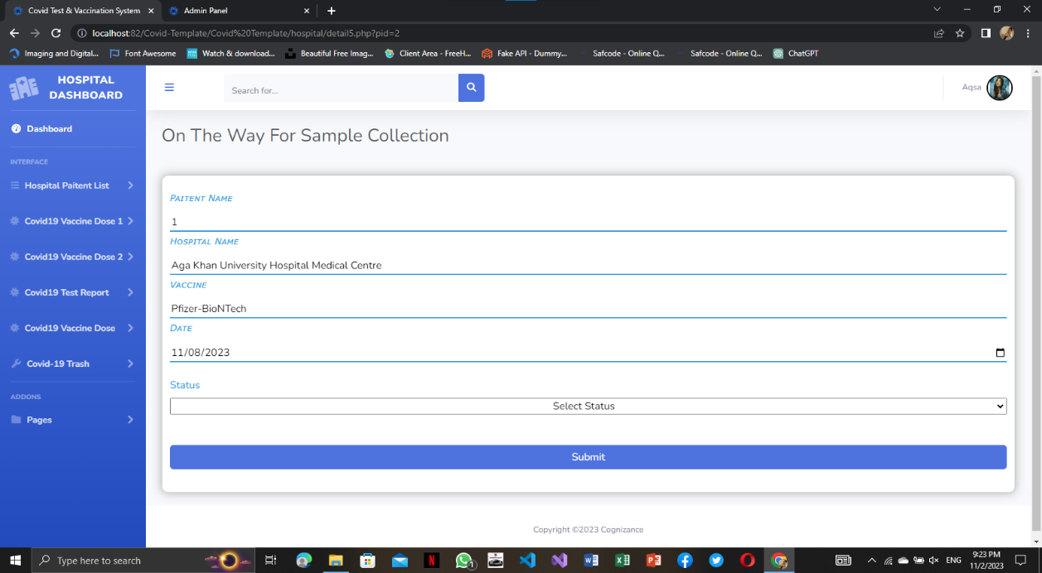

**DOSE 2 WAITING REPORT**

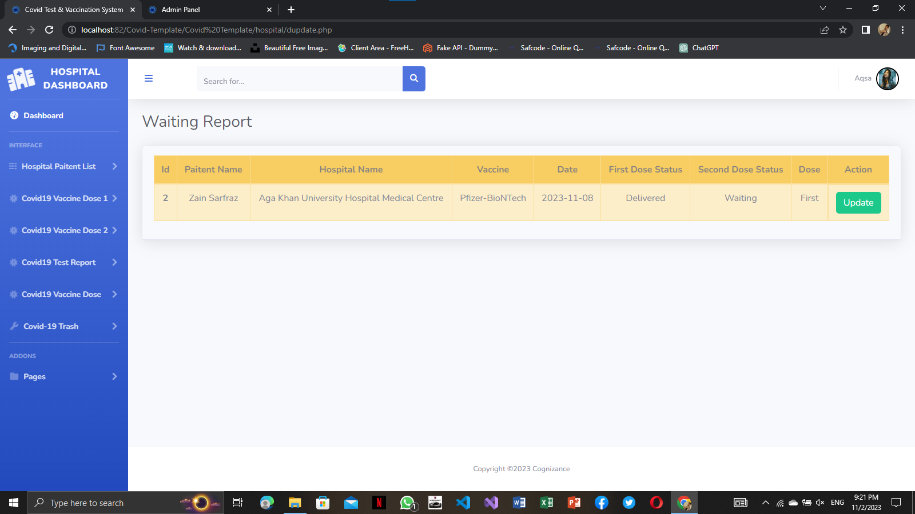

**DOSE 2 WAITING REPORT UPDATE**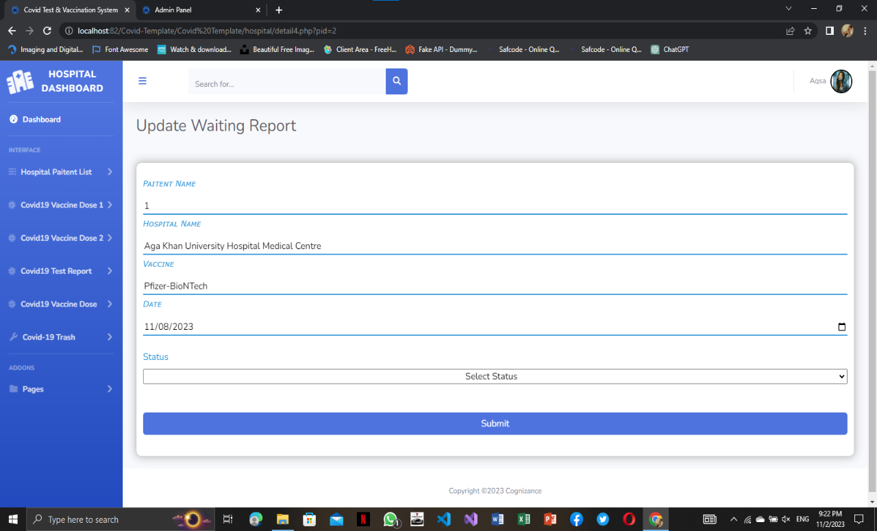

**DOSE 2 DELIVERED REPORT**

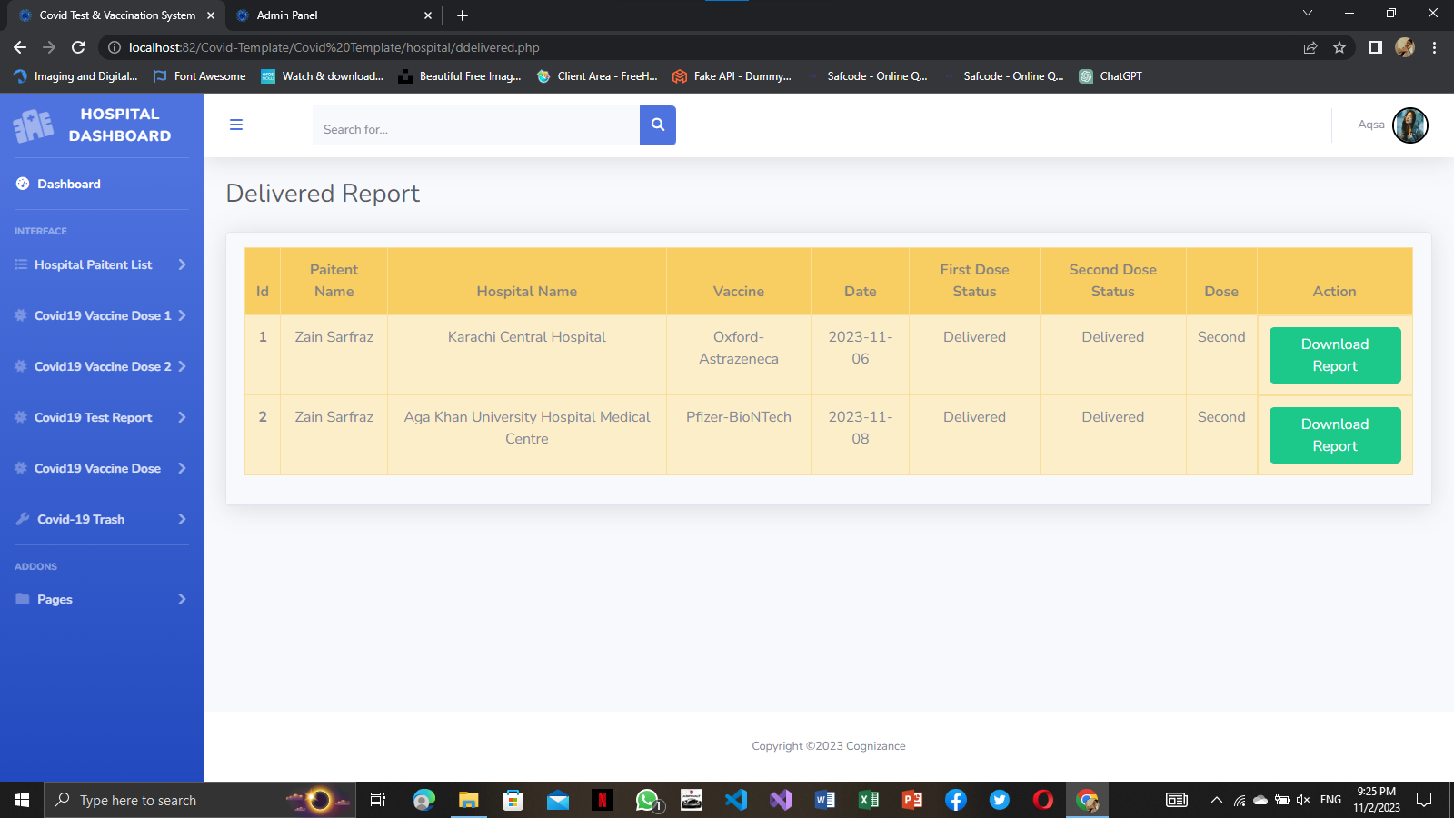

**DOSE 2 WAITING REPORT UPDATE**

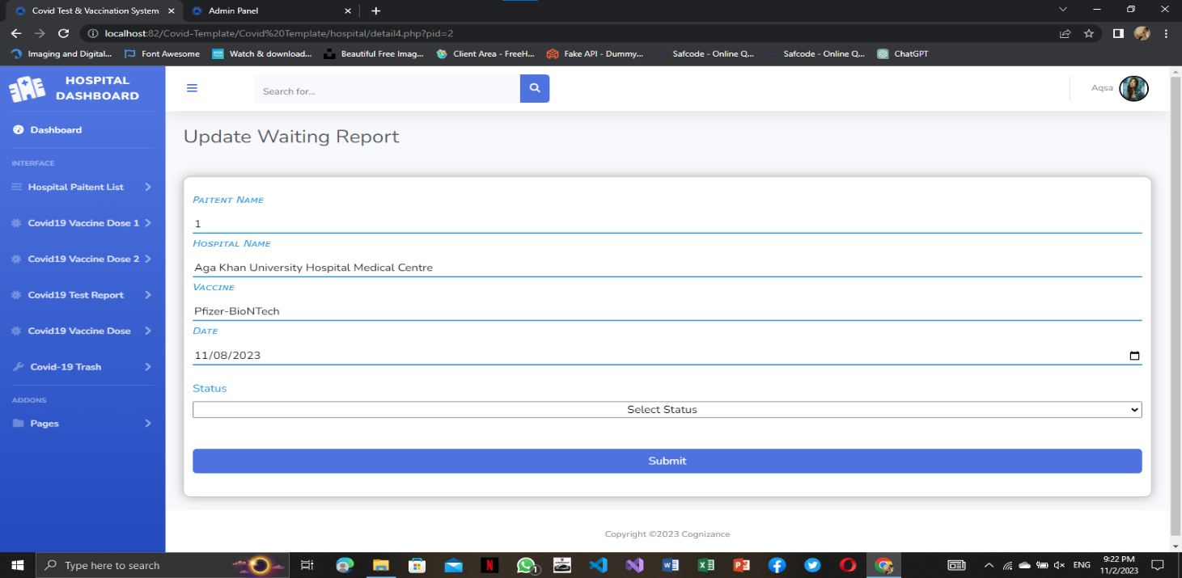

**DOSE 2 SAMPLE COLLECTED UPDATE**

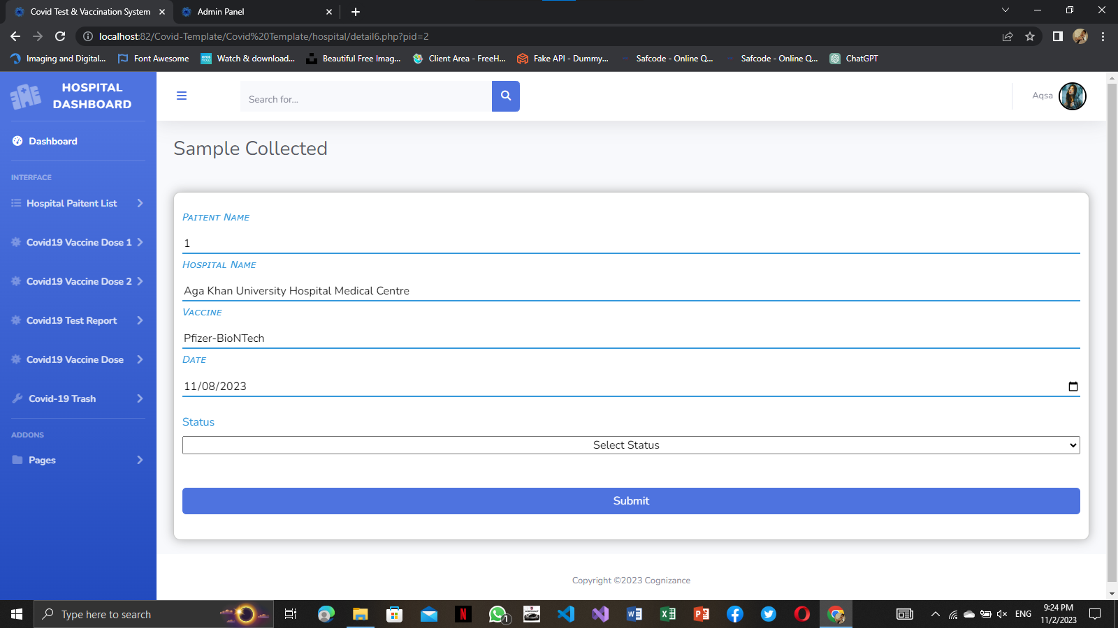

**SAMPLE COLLECTED**

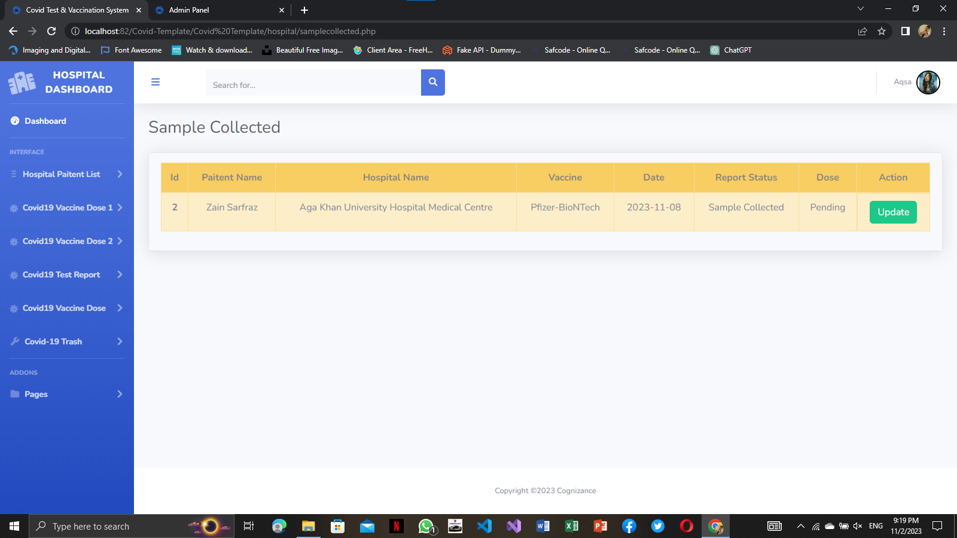

**SAMPLE COLLECTED UPDATE**

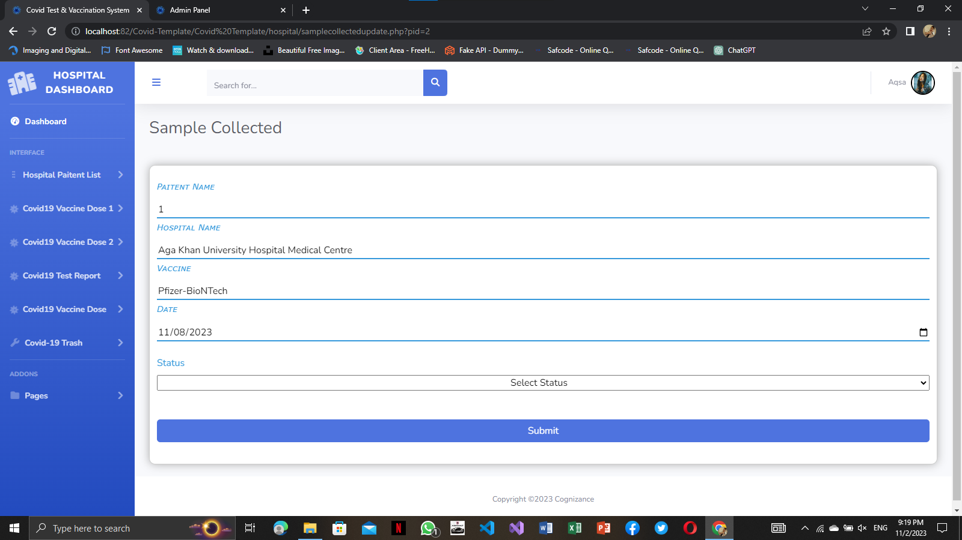

**SENT TO LAB**

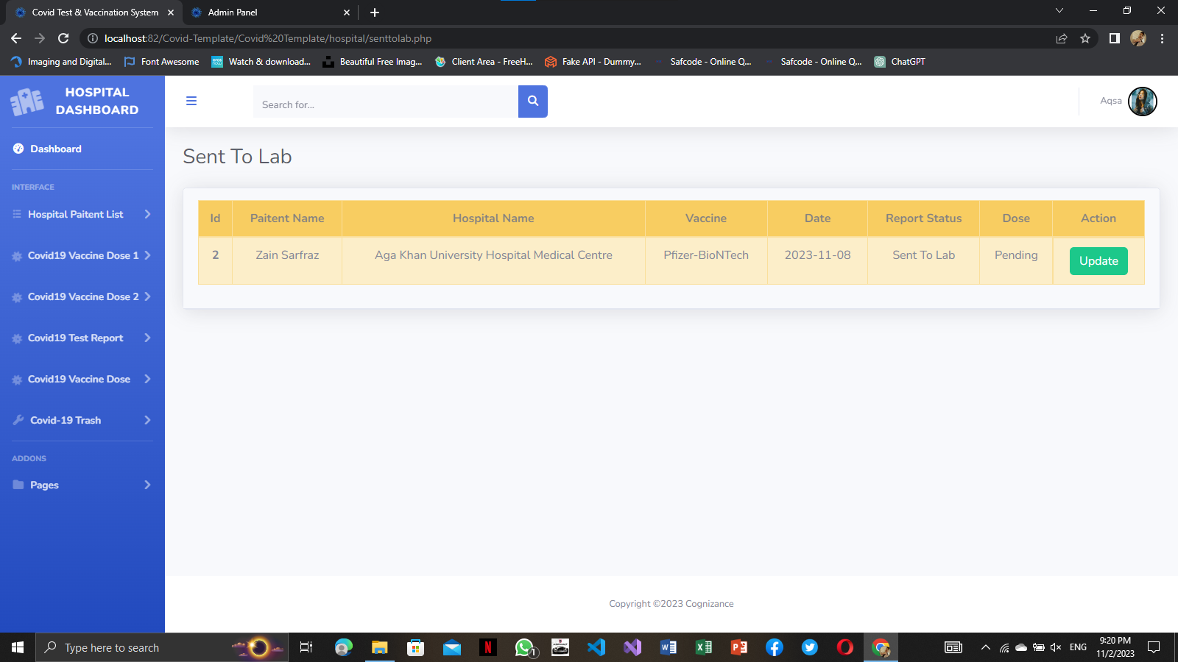

**SEN TO LAB UPDATE**

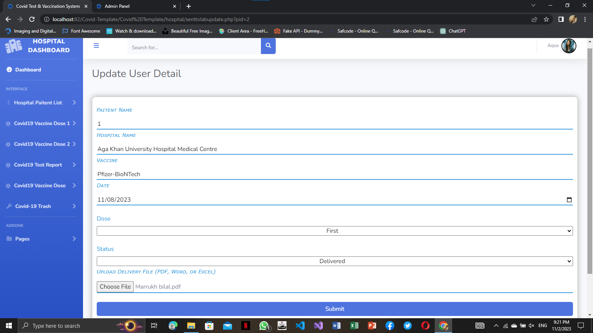

**ON THE WAY REPORT**

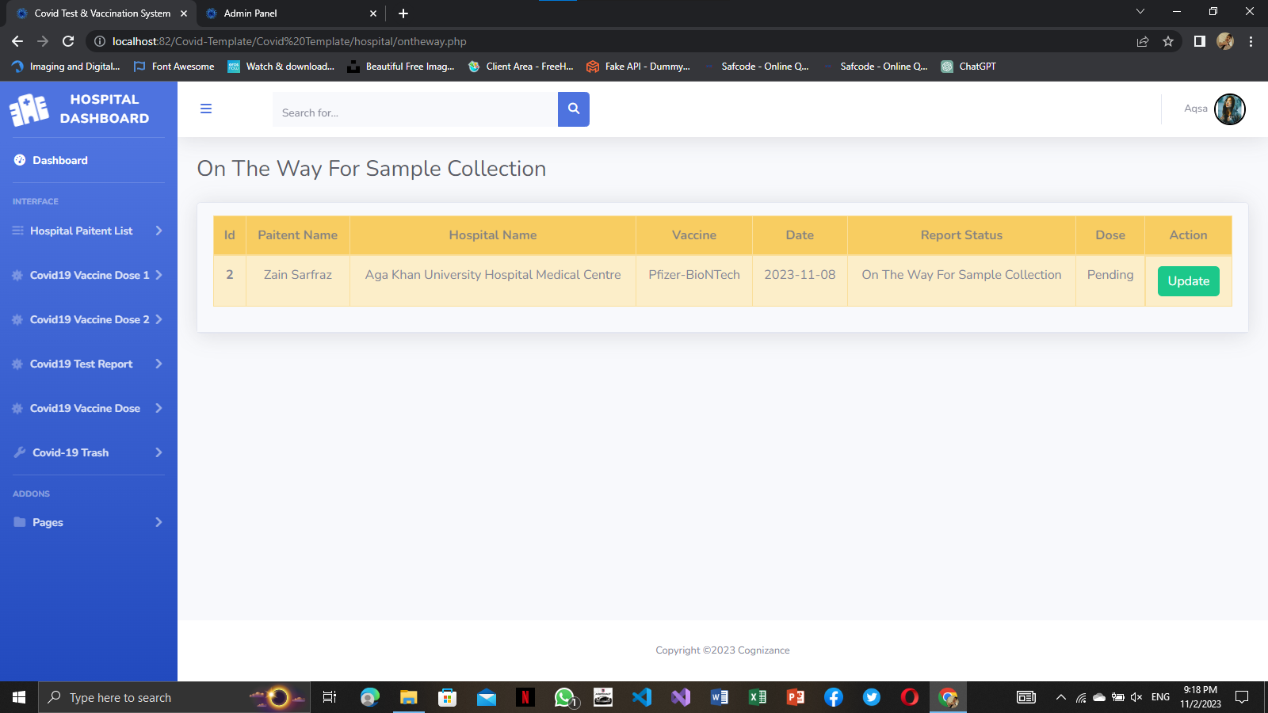

**ON THE WAY UPDATE**

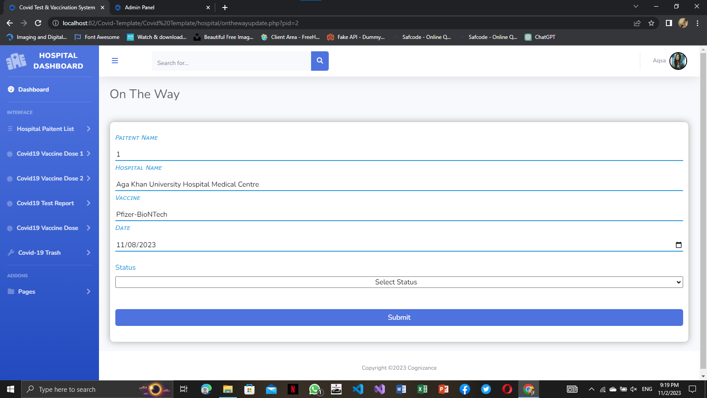

**SECOND DOSE**

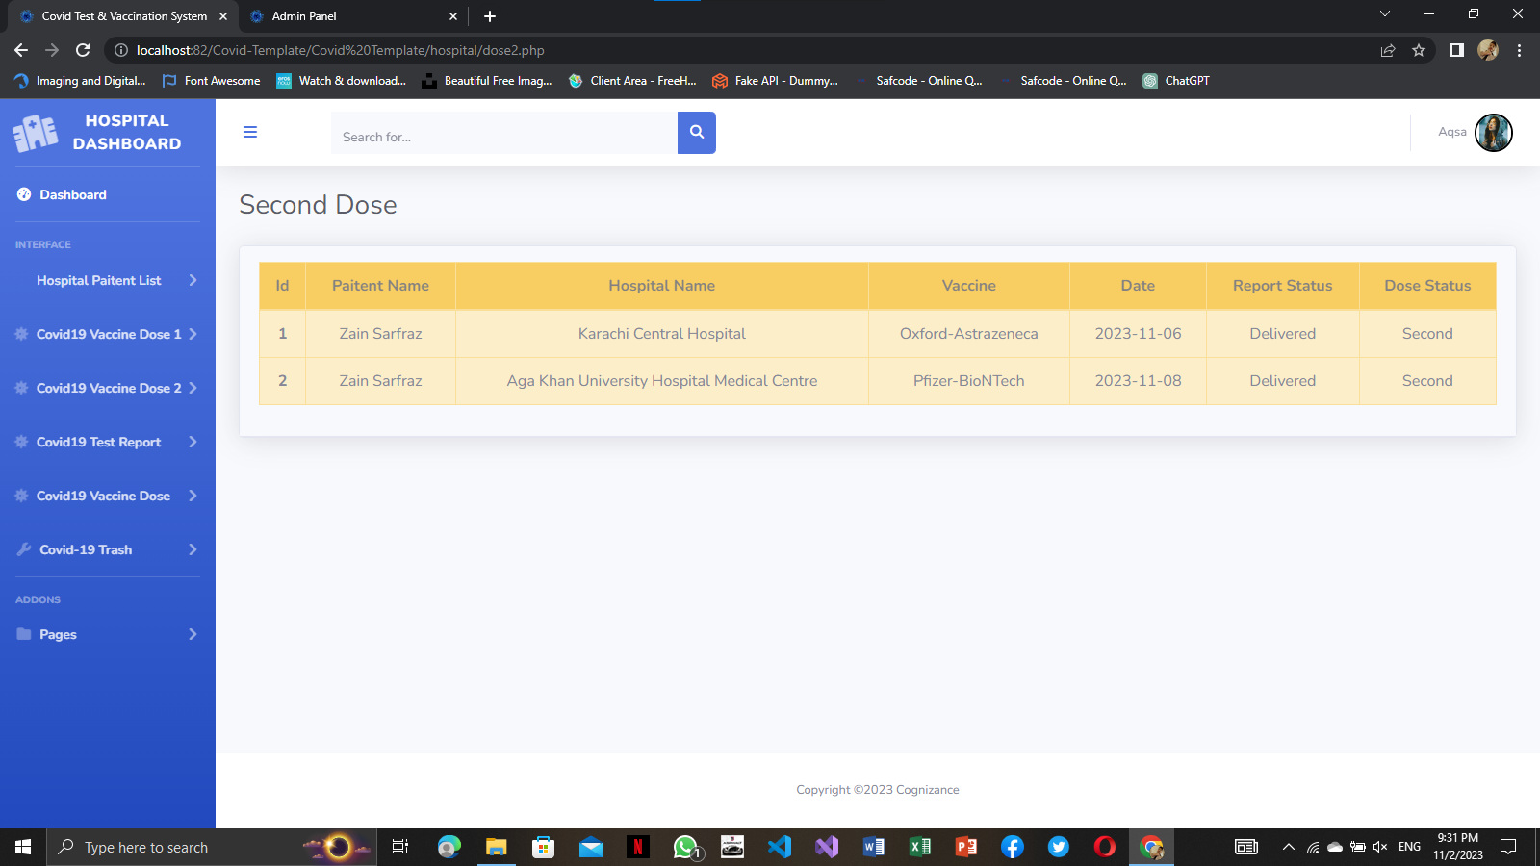

**404**

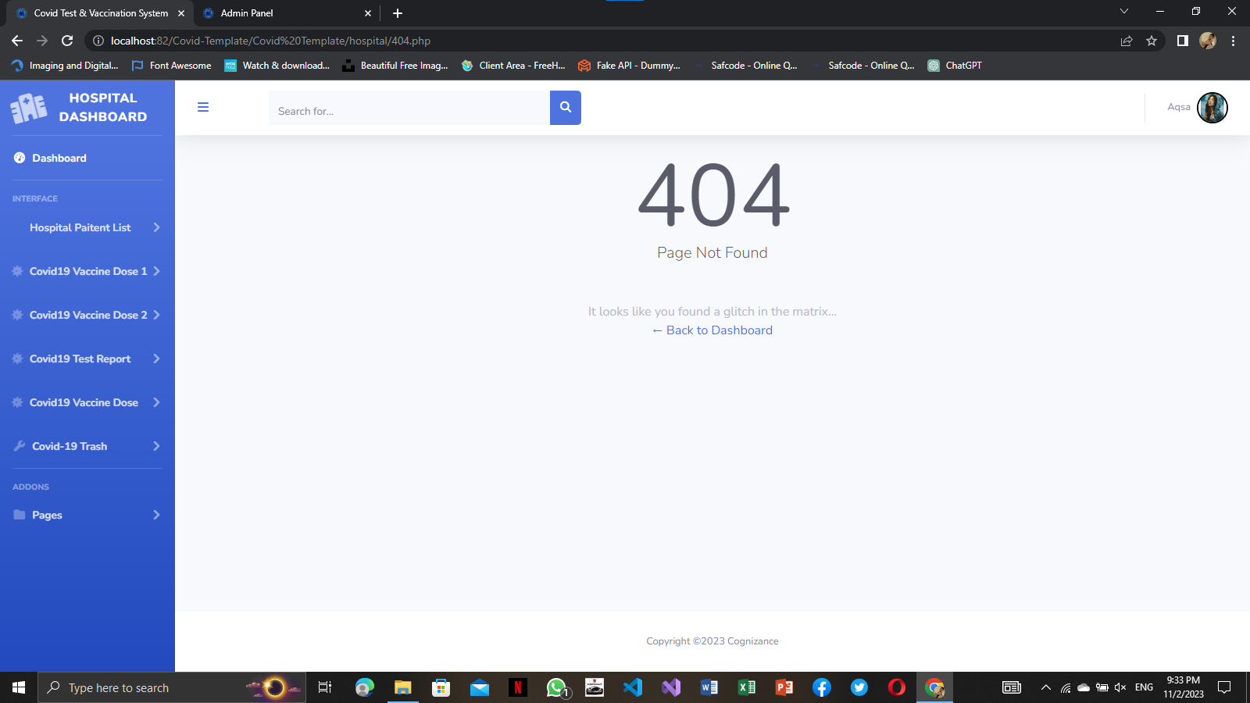

**ALL DOSE REPORT**

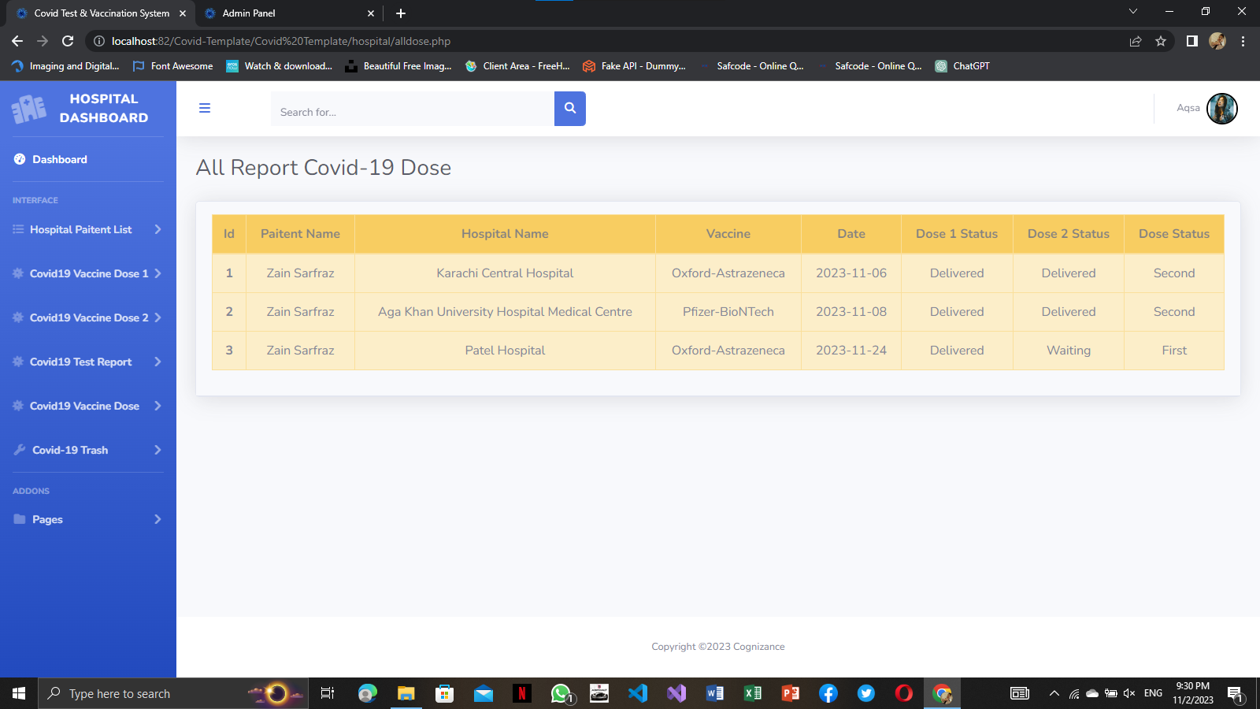

**ALL PATIENT LIST**

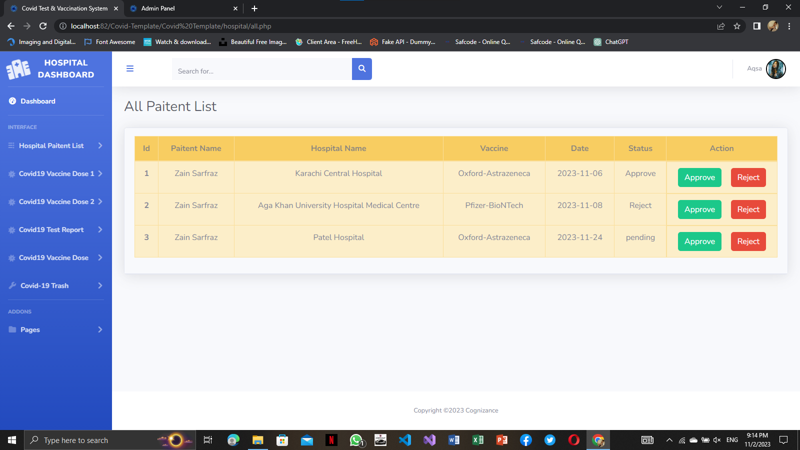

**APPROVE PATIENT**

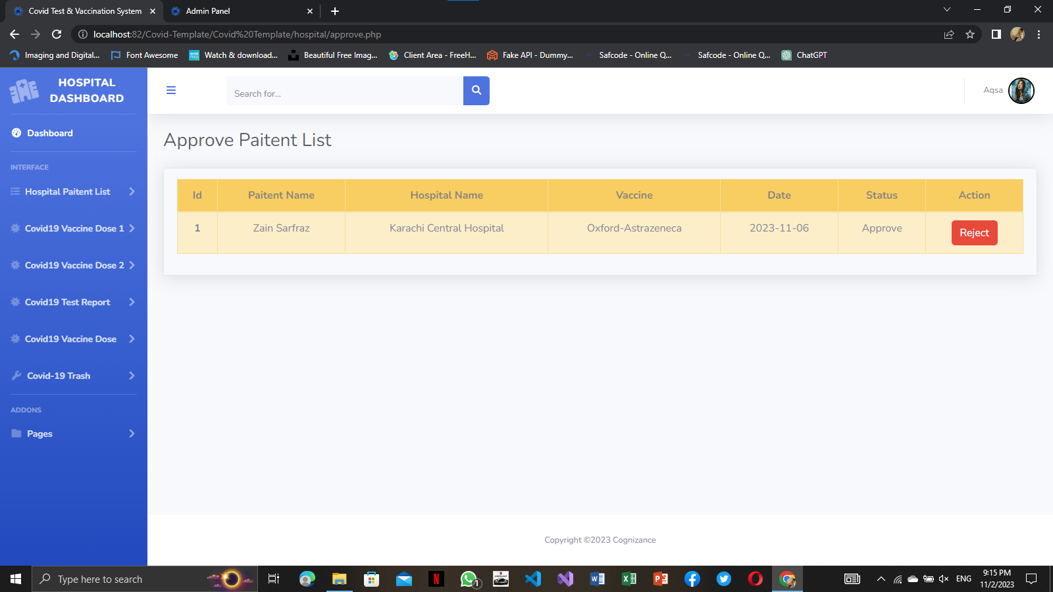

**PENDING PATIENT LIST**

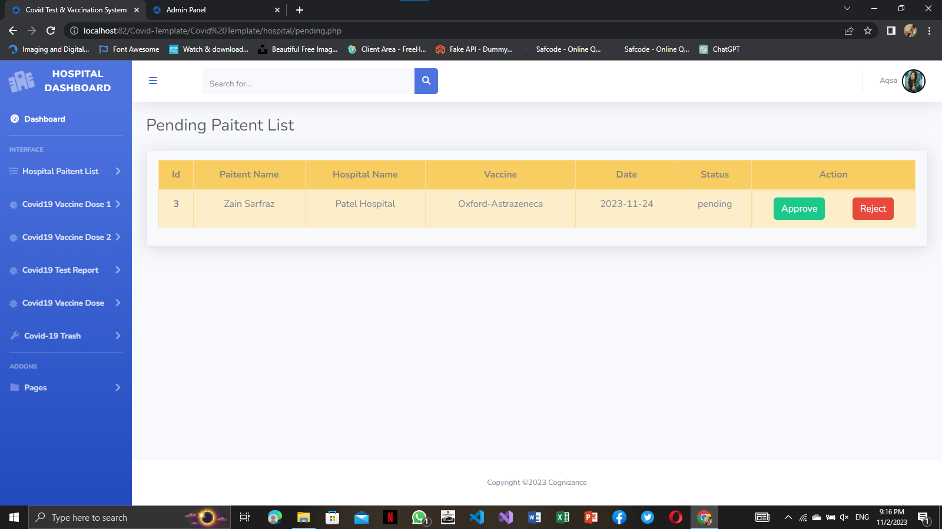

**REJECT PATIENT**

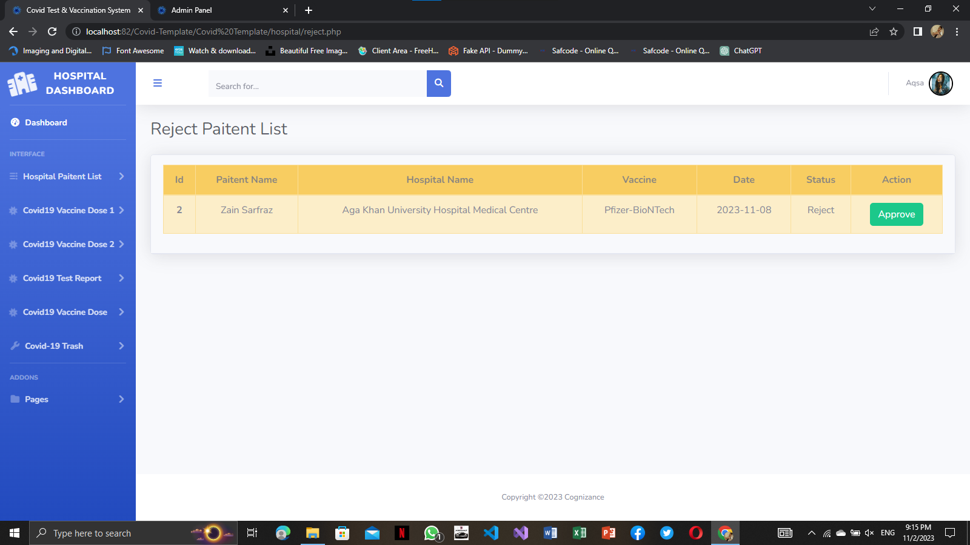

**UPDATE WAITING REPORT**

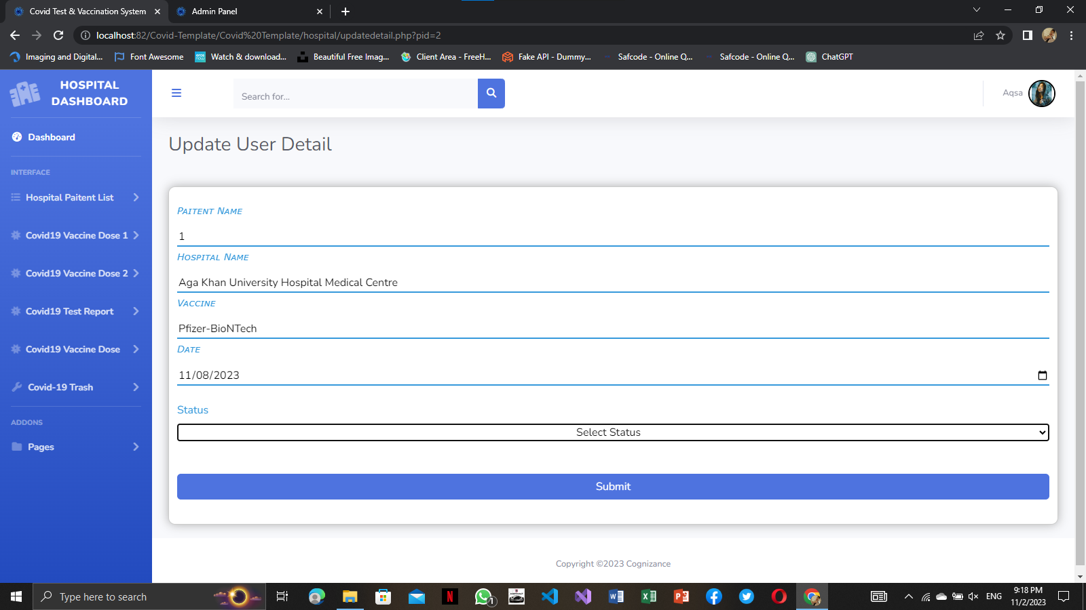

COVID TEST & VACCINATION SYSTEM

**TASKSHEET**

|  |  |  |  |
| --- | --- | --- | --- |
| S# | Task | Team Member Name | Status |
| 1. | Analysis | Zain Sarfraz  Aqsa jabbar  Tooba tariq | ✓ |
| 2. | Design | Zain Sarfraz  Aqsa jabbar  Tooba tariq | ✓ |
| 3. | Development | Zain Sarfraz  Aqsa jabbar  Tooba tariq | ✓ |
| 4. | Documentation | Zain Sarfraz  Aqsa jabbar  Tooba tariq | ✓ |
| 5. | Finalization | Zain Sarfraz  Aqsa jabbar  Tooba tariq | ✓ |

COVID TEST &VACCINATION SYSTEM

# SUBMISSION CHECKLIST

COVID TEST &VACCINATION SYSTEM

**SUBMISSION**

**CHECKLIST**

|  |  |  |  |
| --- | --- | --- | --- |
| S.no | List of items | Remarks | Comments |
| **1.** | Do All Pages Linked  together | **Yes** | ✓ |
| **2.** | Authorization | **Yes** | ✓ |
| **3.** | Crud Operations | **Yes** | ✓ |
| **4.** | Database Connection | **Yes** | ✓ |
| **6.** | Feedback Form  Included | **Yes** | ✓ |
| **7.** | Project Zip File | **Yes** | ✓ |

COVID TEST & VACCINATION SYSTEM

# Conclusion

COVID TEST & VACCINATION SYSTEM

**CONCLUSION**

A covid test & vaccination system has been developed and the system was tested with sample data. The system results in regular timely preparations of required outputs. Provision for addition and deletion of customers is there in the system it is possible to view that proper filling system has been adopted to slate date for future. The entire project runs on windows environments. The system can be used to make better management described at appropriate time. The user gets amount and timely information system.

**THANK YOU!**